


Comply with workplace hygiene procedures
D1.HRS.CL1.05
D1.HOT.CL1.04
D2.TTO.CL4.10
Trainee Manual




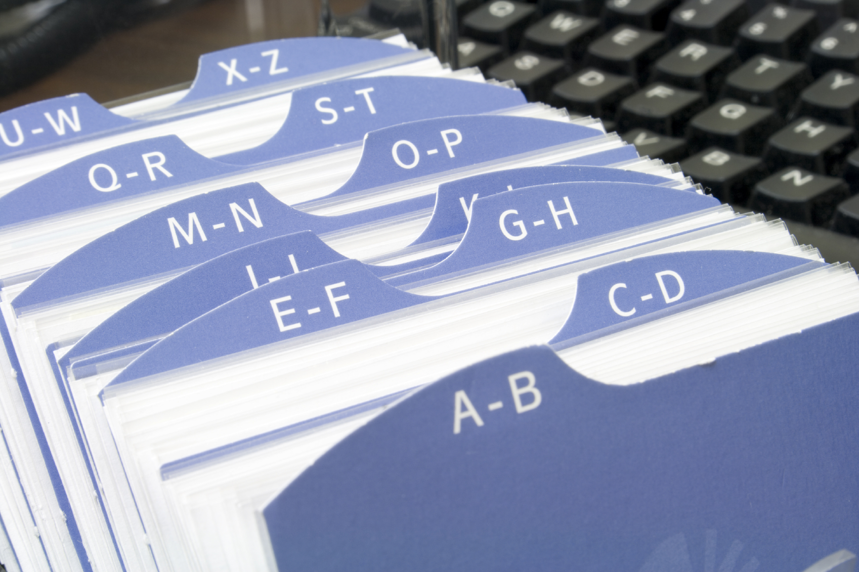
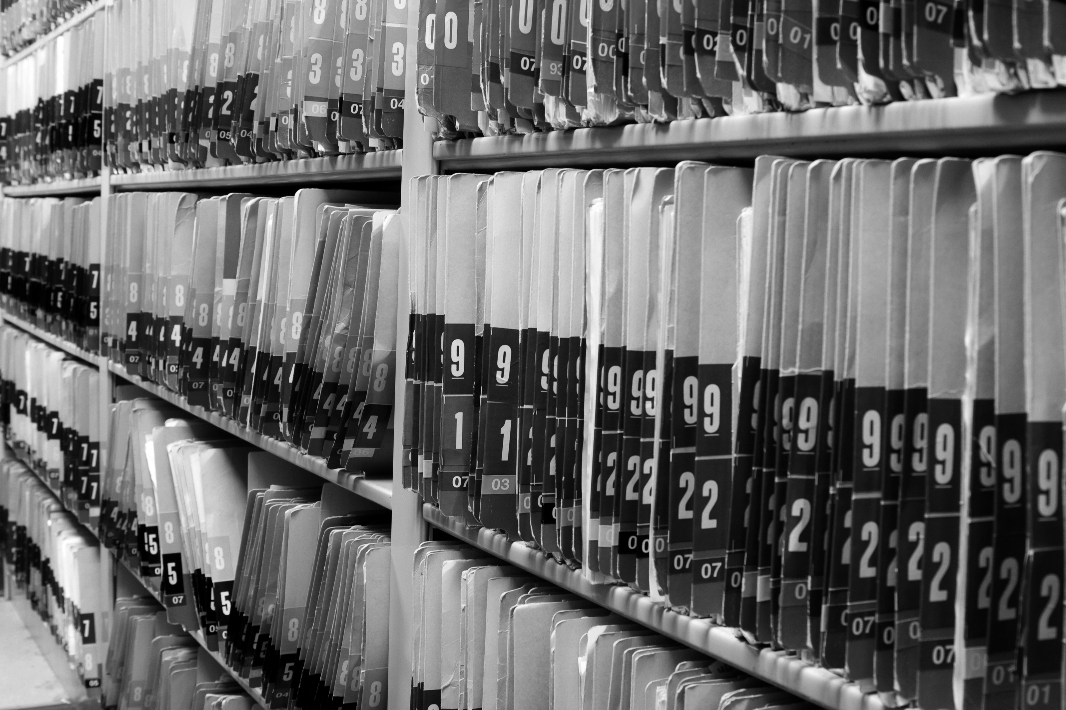

Comply with workplace hygiene procedures

D1.HRS.CL1.05
D1.HOT.CL1.04
D2.TTO.CL4.10

Trainee Manual





Project Base
William Angliss Institute of TAFE
555 La Trobe Street
Melbourne 3000 Victoria
Telephone: | (03) 9606 2111
Facsimile: | (03) 9670 1330
Acknowledgements
Project Director: | Wayne Crosbie
Chief Writer: | Alan Hickman
Subject Writer: | Alan Hickman
Project Manager: | Alan Maguire
Editor: | Jim Irwin
DTP/Production | Daniel Chee, Mai Vu, Jirayu Thangcharoensamut, Kaly Quach

The Association of Southeast Asian Nations (ASEAN) was established on 8 August 1967. The Member States of the Association are Brunei Darussalam, Cambodia, Indonesia, Lao PDR, Malaysia, Myanmar, Philippines, Singapore, Thailand and Viet Nam.
The ASEAN Secretariat is based in Jakarta, Indonesia.
General Information on ASEAN appears online at the ASEAN Website: www.asean.org.
All text is produced by William Angliss Institute of TAFE for the ASEAN Project on “Toolbox Development for Priority Tourism Labour Division”.
This publication is supported by the Australian Government’s aid program through the ASEAN-Australia Development Cooperation Program Phase II (AADCP II).
Copyright: Association of Southeast Asian Nations (ASEAN) 2012.
All rights reserved.
Disclaimer
Every effort has been made to ensure that this publication is free from errors or omissions. However, you should conduct your own enquiries and seek professional advice before relying on any fact, statement or matter contained in this book. The ASEAN Secretariat and William Angliss Institute of TAFE are not responsible for any injury, loss or damage as a result of material included or omitted from this course. Information in this module is current at the time of publication. Time of publication is indicated in the date stamp at the bottom of each page.
Some images appearing in this resource have been purchased from stock photography suppliers Shutterstock and iStockphoto and other third party copyright owners and as such are non-transferable and non-exclusive. Clip arts, font images and illustrations used are from the Microsoft Office Clip Art and Media Library. Some images have been provided by and are the property of William Angliss Institute.
Additional images have been sourced from Flickr and SXC and are used under Creative Commons licence: http://creativecommons.org/licenses/by/2.0/deed.en

File name: TM_Comply_with_workplace_hygiene_Proc_refined





Table of contents
Introduction to trainee manual 1
Unit descriptor 3
Assessment matrix 5
Glossary 7
Element 1: Follow hygiene procedures 9
Element 2: Identify and prevent hygiene risks 49
Element 3: Maintain safe personal food handling and personal presentation standards 73
Presentation of written work 87
Recommended reading 89
Trainee evaluation sheet 91
Trainee self-assessment checklist 93

Introduction to trainee manual

To the Trainee
Congratulations on joining this course. This Trainee Manual is one part of a ‘toolbox’ which is a resource provided to trainees, trainers and assessors to help you become competent in various areas of your work.
The ‘toolbox’ consists of three elements:
- A Trainee Manual for you to read and study at home or in class
- A Trainer Guide with Power Point slides to help your Trainer explain the content of the training material and provide class activities to help with practice
- An Assessment Manual which provides your Assessor with oral and written questions and other assessment tasks to establish whether or not you have achieved competency.
The first thing you may notice is that this training program and the information you find in the Trainee Manual seems different to the textbooks you have used previously. This is because the method of instruction and examination is different. The method used is called Competency based training (CBT) and Competency based assessment (CBA). CBT and CBA is the training and assessment system chosen by ASEAN (Association of South-East Asian Nations) to train people to work in the tourism and hospitality industry throughout all the ASEAN member states.
What is the CBT and CBA system and why has it been adopted by ASEAN?
CBT is a way of training that concentrates on what a worker can do or is required to do at work. The aim is of the training is to enable trainees to perform tasks and duties at a standard expected by employers. CBT seeks to develop the skills, knowledge and attitudes (or recognise the ones the trainee already possesses) to achieve the required competency standard. ASEAN has adopted the CBT/CBA training system as it is able to produce the type of worker that industry is looking for and this therefore increases trainees chances of obtaining employment.
CBA involves collecting evidence and making a judgement of the extent to which a worker can perform his/her duties at the required competency standard. Where a trainee can already demonstrate a degree of competency, either due to prior training or work experience, a process of ‘Recognition of Prior Learning’ (RPL) is available to trainees to recognise this. Please speak to your trainer about RPL if you think this applies to you.
What is a competency standard?
Competency standards are descriptions of the skills and knowledge required to perform a task or activity at the level of a required standard.
242 competency standards for the tourism and hospitality industries throughout the ASEAN region have been developed to cover all the knowledge, skills and attitudes required to work in the following occupational areas:
- Housekeeping
- Food Production
- Food and Beverage Service
- Front Office
- Travel Agencies
- Tour Operations.
All of these competency standards are available for you to look at. In fact you will find a summary of each one at the beginning of each Trainee Manual under the heading ‘Unit Descriptor’. The unit descriptor describes the content of the unit you will be studying in the Trainee Manual and provides a table of contents which are divided up into ‘Elements’ and ‘Performance Criteria”. An element is a description of one aspect of what has to be achieved in the workplace. The ‘Performance Criteria’ below each element details the level of performance that needs to be demonstrated to be declared competent.
There are other components of the competency standard:
- Unit Title: statement about what is to be done in the workplace
- Unit Number: unique number identifying the particular competency
- Nominal hours: number of classroom or practical hours usually needed to complete the competency. We call them ‘nominal’ hours because they can vary e.g. sometimes it will take an individual less time to complete a unit of competency because he/she has prior knowledge or work experience in that area.
The final heading you will see before you start reading the Trainee Manual is the ‘Assessment Matrix’. Competency based assessment requires trainees to be assessed in at least 2 – 3 different ways, one of which must be practical. This section outlines three ways assessment can be carried out and includes work projects, written questions and oral questions. The matrix is designed to show you which performance criteria will be assessed and how they will be assessed. Your trainer and/or assessor may also use other assessment methods including ‘Observation Checklist’ and ‘Third Party Statement’. An observation checklist is a way of recording how you perform at work and a third party statement is a statement by a supervisor or employer about the degree of competence they believe you have achieved. This can be based on observing your workplace performance, inspecting your work or gaining feedback from fellow workers.
Your trainer and/or assessor may use other methods to assess you such as:
- Journals
- Oral presentations
- Role plays
- Log books
- Group projects
- Practical demonstrations.
Remember your trainer is there to help you succeed and become competent. Please feel free to ask him or her for more explanation of what you have just read and of what is expected from you and best wishes for your future studies and future career in tourism and hospitality.

Unit descriptor
Comply with workplace hygiene procedures
This unit deals with the skills and knowledge required to Comply with workplace hygiene procedures in a range of settings within the hotel and travel industries workplace context.
Unit Code:
D1.HRS.CL1.05
D1.HOT.CL1.04
D2.TTO.CL4.10
Nominal Hours:
20 hours

Element 1: Follow hygiene procedures
Performance Criteria
1.1 Identify relevant workplace hygiene procedures that need to be adhered to
1.2 Identify enterprise standards and legislated requirements that apply to relevant workplace hygiene procedures
1.3 Follow workplace hygiene procedures in accordance with enterprise standards and legislated requirements
1.4 Receive, handle and store all food items according to enterprise standards and legislated requirements
1.5 Prepare, serve and store food in compliance with enterprise standards and legislated requirements
1.6 Clean food-related items, utensils and areas in compliance with enterprise standards and legislated requirements

Element 2: Identify and prevent hygiene risks
Performance Criteria
2.1 Identify potential food, personal, environmental and other risks in the workplace promptly
2.2 Take action to minimise or remove the risk of food contamination within the scope of individual responsibility
2.3 Handle and dispose of food waste and rubbish in compliance with enterprise standards and legislated requirements

Element 3: Maintain safe personal food handling and personal presentation standards
Performance Criteria
3.1 Identify the enterprise standards and legislated requirements that apply to personal practices and presentation for food handling staff
3.2 Follow enterprise standards and legislated requirements that apply personal practices and presentation for food handling staff
Notes in this unit rely heavily on the information provided in ‘Safe Food Australia: A Guide to the Food Safety Standards, 2nd edition, January 2001 – Chapter 3 of the Australian New Zealand Standards Code’ and the use of this resource is hereby acknowledged with appreciation.
This publication is available for free download at http://www.foodstandards.gov.au/newsroom/publications/safefoodaustralia2nd519.cfm.
All students are advised to obtain and read this document.

Assessment matrix
Showing mapping of Performance Criteria against Work Projects, Written Questions and Oral Questions
The Assessment Matrix indicates three of the most common assessment activities your Assessor may use to assess your understanding of the content of this manual and your performance - Work Projects, Written Questions and Oral Questions. It also indicates where you can find the subject content related to these assessment activities in the Trainee Manual (i.e. under which element or performance criteria). As explained in the Introduction, however, the assessors are free to choose which assessment activities are most suitable to best capture evidence of competency as they deem appropriate for individual students.
 |  |  | Work Projects | Written Questions | Oral Questions
Element 1: Follow hygiene procedures
1.1 | Identify relevant workplace hygiene procedures that need to be adhered to |  | 1.1 | 1, 2, 3 | 1
1.2 | Identify enterprise standards and legislated requirements that apply to relevant workplace hygiene procedures |  | 1.1 | 4 – 9 | 2
1.3 | Follow workplace hygiene procedures in accordance with enterprise standards and legislated requirements |  | 1.2 | 10 – 14 | 3
1.4 | Receive, handle and store all food items according to enterprise standards and legislated requirements |  | 1.2 | 15 – 21 | 4
1.5 | Prepare, serve and store food in compliance with enterprise standards and legislated requirements |  | 1.2 | 22 – 28 | 5
1.6 | Clean food-related items, utensils and areas in compliance with enterprise standards and legislated requirements |  | 1.3 | 29 – 33 | 6
Element 2: Identify and prevent hygiene risks
2.1 |  | Identify potential food, personal, environmental and other risks in the workplace promptly | 2.1 | 34 – 41 | 7
2.2 |  | Take action to minimise or remove the risk of food contamination within the scope of individual responsibility | 2.1 | 42 – 46 | 8
2.3 |  | Handle and dispose of food waste and rubbish in compliance with enterprise standards and legislated requirements | 2.2 | 47, 48 | 9
Element 3: Maintain safe personal food handling and personal presentation standards
3.1 | Identify the enterprise standards and legislated requirements that apply to personal practices and presentation for food handling staff |  | 1.1 | 49 | 10
3.2 | Follow enterprise standards and legislated requirements that apply personal practices and presentation for food handling staff |  | 3.1 | 50 – 56 | 11

Glossary
Term | Explanation
Bain marie | A French term: a hot holding device used to keep hot foods hot for service and display
Cross contamination | The result of transferring bacteria/contamination from one area/item to another
De-naturing agent | A chemical or colouring agent added to draught beer drip trays to change the quality and/or colour of waste beer in order to prevent operators re-using it, re-selling it or pouring it back into kegs
Deodoriser | Chemical used to control odours
FIFO | First In – First Out method of stock rotation
MSDS | Material Safety Data Sheet – safety sheets for chemicals providing advice about what to do in the case of an accident/emergency involving the chemical
PR | Public relations
Pathogen | Disease-causing organism
Plate waste | Food coming back from customers on plates/in glasses after they have finished their meal/drinks
Potentially hazardous food | Food known to be commonly associated with food poisoning outbreaks; it is usually high protein, high moisture and low acid foods. Also known as ‘High risk food’ or ‘Potentially dangerous food’
SOP | Standard Operating Procedure
Service gear | Any cutlery, crockery or similar used to present and/or serve food to customers
Temperature Danger Zone | The temperature range in which bacteria multiply most rapidly: 5°C - 60°C
Thawing food | Defrosting food
Toxin | Poison
Vermin | Pests and rodents
Working dirt | The dirt generated as a result of undertaking your normal food-related duties for a shift. It does not refer to dirt from a previous shift or day
OSH | OSH refers to Occupational Safety and Health. In some countries the term OHS ‘Occupational Health and Safety’ is used. The concept is identical and relates to workplace safety and health policies, procedures and practices

Element 1:
Follow hygiene procedures

1.1 Identify relevant workplace hygiene procedures that need to be adhered to

Introduction
Food handlers are required to comply with workplace and legislated requirements to ensure the safety of food prepared and served for human consumption.
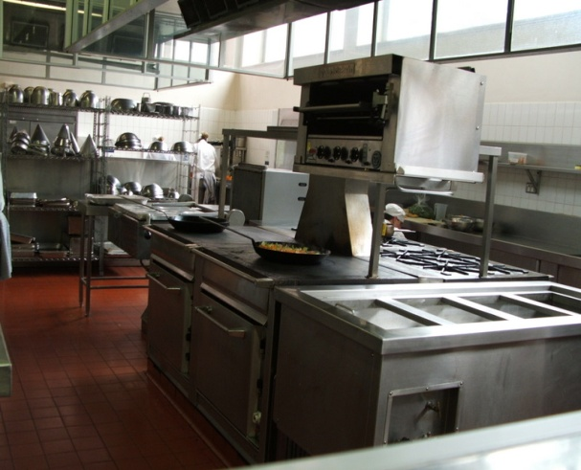
This Section describes how you can identify the workplace food safety procedures to be complied with and how you can access them to learn what needs to be done to create and maintain a safe food environment.

Workplace requirements
In your workplace you will be expected to comply with safe food handling practices as indicated by three possible sources:
- Legislation – which can include national legislation, regional legislation and/or local legislation
- Enterprise policies and procedures – as determined by the individual employer
- The requirements of any internal safe food handling system implemented by the business – these may be a legal requirement or they may be in addition to other legislated obligations imposed by law on a food premises.
Legislation
You must research the requirements of any legislation impacting on your workplace to determine the specifics of the legally imposed obligations you, personally, and the business where you work are under.
To do this:
- Speak with management, the owner, your supervisor and/or more senior staff and enquire about what applies where you work
- Visit your local health/food safety authority in-person and ask them what applies and what obligations you are under
- Research the requirements on the internet.

Enterprise policies and procedures
Policies and procedures will vary between businesses however all operations can be expected to have internal requirements reflecting their legislated obligations and addressing identified workplace food safety hazards.
Potentially, food safety hazards exist in every food premises at every stage of food handling:
- Purchasing food for use in the premises
- Receiving goods from suppliers into the premises
- Food storage prior to preparation and/or service
- De-frosting/thawing frozen food
- Preparing of raw materials for sale/service and the cooking food (including the cooling hot food for storage after it has been cooked)
- Cold holding and hot holding and display of prepared food for sale/service
- Re-heating of prepared food
- Serving food
- Self-service of food by customers to themselves.
In addition, workplace policies and procedures can be expected to exist to address other food safety-related issues such as:
- Cleaning and sanitising of food utensils, equipment, areas and food contact and preparation surfaces
- Specific food handling techniques required by the workplace to optimise food safety – as applicable to the equipment they use, the food they prepare and other factors applying in the premises
- Personal hygiene – and requirements applying to ensure staff do not contaminate food by their actions
- Equipment maintenance – and the need to keep food equipment, utensils (including food thermometers) and areas properly maintained to ensure they operate as required (for example, it is important for refrigerators, freezers and hot and cold holding units to reach the temperatures they are supposed to reach)
- Use of food thermometers – to check food and equipment temperatures

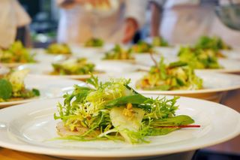
- Pest control – to control vermin
- Waste disposal – to enable the proper removal of waste from kitchens and from the garbage storage area
- Food recalls – to allow unsafe food to be recalled and safely disposed of.
In some cases, workplace policies and procedures will be more strict/severe than the legally imposed requirements – for example, the law may require you to keep refrigerated food ‘at 5°C or below’ but an enterprise policy may require the food be kept at ‘at 4°C or below’.
Internal safe food handling systems
Organisational requirements for safe food handling may (also) be contained within a system known as a ‘Food Safety Plan’ or ‘Food Safety Program’, or similar.
This system may be legally imposed on the business and apply to all food premises in the country, or it may be a system the workplace voluntarily imposes on itself in order to optimise the safety of the food it serves/sells.
Such a system will:
- Identify the workplace food safety hazards – at each stage of the food handling process and in all areas where food is handled
- Describe specific action you must take to keep food safe at the premises – these are known as ‘safe food handling practices and procedures’ designed to keep food ‘under control’ (meaning the food is always handled and stored within parameters [of time and temperature] to ensure it remains ‘under control’ and hence safe to eat)
- Describe specific action you must take if the food becomes unsafe – such as recalling the food from sale/consumption, disposing of it and investigating the cause of the ‘out of control’ situation so remedial action can be taken to prevent a recurrence of the problem
- Identify the records to be kept to assist you maintain a safe food environment, and allow you to prove you have done so. These records must be completed ‘as required’ for the individual record type and it is a vital part of your job, where these records exist, to complete them fully as required and when required. Types of records to be kept will vary depending on the food safety system being used but can include:
- Approved Food Suppliers List – listing those businesses from whom your workplace is allowed to buy food: if a business is not named on this list you are not allowed to purchase food (or beverages) from it
- Goods Receiving Form – requiring you to record a proportion (say, 5%) of all inwards food deliveries, detailing the food delivered, the name of the supplier and the temperature of all hot, cold and frozen food delivered into the premises
- Cold Storage Temperature Log – recording the daily temperatures of fridges, freezers and coolrooms
- Ready To Eat Food On Display Log – recording the daily temperatures of both hot and cold foods while they are stored for display/sale to the public in units such as bain maries, salad wells and other refrigerated or hot display units
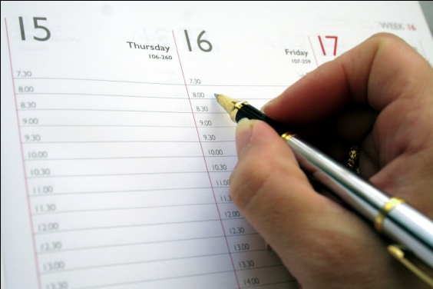
- Equipment Calibration Log – recording the testing of ‘probe thermometers’ to prove they are providing accurate readings, or to show they need repair/replacement
- Internal Review Process temperature Log – detailing on some regular basis (such as once every 2 weeks) the processing of a food item by tracking and recording the processes used (thawing, preparing, cooking, cooling, re-heating, displaying, serving) and recording the times and temperatures involved at each process step.
All these records must be maintained and archived, and be available for inspection by your employer.
Where a premises uses these records this means you will be required to record relevant data (times, temperatures, names of suppliers, details of food items) on the various records the business maintains. Your on-the-job training will identify requirements in this regard.
Asking questions
It is extremely important you understand that in order to fully identify and understand all the relevant workplace safe food handling and food hygiene requirements needing to be adhered to:
- You must always ask questions or seek clarification about any issue you are unsure about
- You must never be afraid to ask questions – do not let the fear of looking foolish stop you asking a question
- When in doubt – ask!

1.2 Identify enterprise standards and legislated requirements that apply to relevant workplace hygiene procedures

Introduction
Workplace hygiene procedures are practices used to control the safety of food making it fit for human consumption/safe to eat.
These procedures cover processes from the purchasing of food for the premises through to the disposal of waste produced as a result of food processing activities.
This Section identifies possible standards and possible legislated requirements that may apply to your workplace.
Note
In all situations where these notes differ to what is required by your host country legislation, or by your employer, always follow the requirements of the legislation and your workplace.

Enterprise standards and legislated requirements
As indicated in the previous Section, enterprise standards and legislated requirements will include:
- Details of policies and procedure of the host enterprise
- Details of the food standards that the enterprise has determined as appropriate
- Details of the statutory requirements of the legislation of the host country.

Examples of relevant standards and requirements
The following identifies important food safety standards, requirements, terminology and practices in relation to safe food.
Potentially hazardous food
Potentially hazardous food is food that must be stored under special temperature conditions to prevent the growth of food poisoning bacteria, or to prevent the formation of toxins in the food.
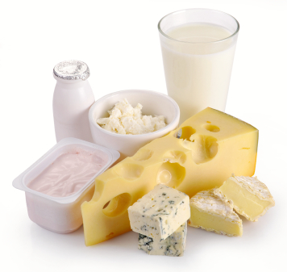
Potentially hazardous food focuses on high protein, high moisture, and low acid foods.
You must pay special attention to the following ‘potentially hazardous foods’ and make sure they are stored correctly at the right temperature (that is, out of the Temperature Danger Zone – see below):
- Milk and milk products, soft cheeses – butter, yoghurt, custards, cream cakes, cheese, baked custard tarts and dips
- Egg products – quiche, fresh pasta, duck and game bird eggs, all eggs, mayonnaise (whole egg)
- Meat and poultry – all cuts and types. Includes beef, ham, veal, pork, chicken, turkey – includes legs, mince, steaks, chops, cutlets, breast, wings
- Smallgoods products – ham, pressed chicken, but note most salami is not a high risk food due to its high salt and low moisture content
- Processed meat products including chicken – paté, meat pies, sausages, sausage rolls, coagulated blood (in, for example, black pudding), rissoles, meat balls
- Fish, shellfish, fish products, fish soups and fish stocks – caviar, fish balls, patties, salads, sauces and stews
- Other prepared food dishes containing high risk food products – pizza, prepared meals, pre-made sandwiches and rolls, salads and cooked rice and cooked pasta.
Temperature Danger Zone
It is important to know the Temperature Danger Zone because it is the temperature range in which bacteria multiply most rapidly.
The range is 5°C - 60°C.
Every effort must be made to keep potentially hazardous food out of this temperature range.
Where food must to be in this range (such as when it is being prepared), the amount of time the food spends in this zone must be minimised.
It is important to note all time food spends in the Temperature Danger Zone is cumulative.
For example, if a piece of meat is left out on the bench for one hour, refrigerated and then brought back out into the kitchen, the time it then spends in the Temperature Danger Zone is added to the previous time – the clock (and the bacteria count) does not get reset to zero when the food was put in the fridge again.
The 2/4 Rule
Awareness of the 2/4 rule is critical in applying safe food handling procedures.
The 2/4 rule states:
- Potentially hazardous foods that have been in the Temperature Danger Zone for 4 hours (or more) must be discarded/thrown out
- Potentially hazardous foods that have been in the Temperature Danger Zone for 2 hours can be refrigerated and then returned to the Temperature Danger Zone for another 2 hours, maximum
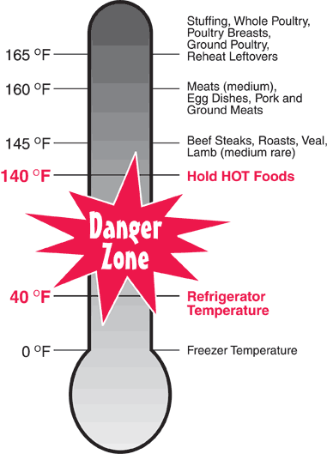
- When high risk food has been in the Temperature Danger Zone for 2 hours it must be cooked or eaten within the next 2 hours or thrown out.
There are no exceptions to this rule.
Calibrated food thermometer
All food premises should have at least one independent, calibrated food thermometer available to check the temperature of food (on delivery, during processing, while on display), and food equipment (such as fridges, coolrooms, freezers, bain-maries, food warmers).
It is best to use a probe thermometer which can be inserted into food.
The use of infra-red thermometers is not recommended as they will only give surface temperature readings which are not accurate enough for food safety purposes.
This thermometer must be:
- Readily available for food handling staff to use as required – it should not be locked away in an office where you cannot obtain it easily
- Checked/calibrated very six months (minimum) to ensure it is giving an accurate reading. Instructions on how to do a hot and cold calibration to check the accuracy of the thermometer are sometimes included in the instructions accompanying the thermometer
- Thermometers must be accurate to +/- 1°C or they must be repaired or replaced
- Cleaned and sanitised between uses when it is being used to check the temperature of food – the use of a sanitising wipe to clean and sanitise the probe is common

- Allowed to reach room temperature when being alternated between use on hot and cold food or vice versa – to allow the thermometer to reach ambient temperature before being used
- Treated with care – do not knock, drop or damage it: if it is knocked, dropped or damaged, it should be immediately checked for accuracy.
Standards for working in the bar area
Many staff working in a bar do not see themselves as working in a ‘food’ environment however it is important to remember (by definition) all beverages are ‘food’ and all the requirements applying to safe food handling also apply to beverages.
The following actions are especially applicable for those who work behind a bar:

- Use a fork or tongs when putting fruit or ice in a glass – do not use fingers
- Do not re-use any fruit, straws, beverage, food, garnish left by a customer, or which comes back from the tables – all plate waste must be thrown out
- Ensure drinking straws are correctly stored – they must be stored so they are kept free from flies, dust and contamination. They must be able to be obtained one at a time without other straws being touched meaning it is not acceptable to store straws in a glass or other container on the bar
- Check glass washing machine has detergent, and is operating at the prescribed temperature which is 70°C
- Put de-naturing agent in drip trays (drip trays are trays which are placed under beer drawing taps to catch the drips/overflow from glasses) – there must be sufficient de-naturing agent to actually de-nature the waste beer and stop the premises pouring this waste beer back into the beer keg or otherwise re-using it
- No smoking or spitting behind the bar
- Wash hands at all times that kitchen-based food handlers are required to wash their hands – see 3.2 for details on effective hand washing for food handlers
- Ensure clean clothes, hands and fingernails whenever working in a bar – the same standards apply to bar staff as to kitchen workers and other food handlers
- Stay away from work if ill or suffering from an infected cut. You should notify your doctor of your status as a food handler so they can ensure you are fit to return to work, free from disease, after an illness. Many employers require food handlers to provide a medical clearance/certificate after an absence from work due to illness declaring their fitness for work on return
- Ensure all glassware and utensils are clean – plates and glasses must also be free of chips and cracks.

1.3 Follow workplace hygiene procedures in accordance with enterprise standards and legislated requirements

Introduction
It is vital all workplace hygiene procedures are complied with at all times, without exception.
This Section presents several workplace hygiene procedures that will enable identified workplace food safety hazards to be effectively addressed.

Personal hygiene
As a food handler you must be aware you, your actions, your health, and your personal habits have a great impact on the safety and quality of food served to the public.
Personal hygiene is a serious issue and must be treated as such.
The industry simply cannot afford to tolerate workers who treat it as a joke. You are regarded by customers and employers as a professional and must therefore know what is expected in this regard, cultivate sound work practices, and be vigilant in ensuring personal hygiene requirements are complied with.
In general terms all food handlers are under an obligation to observe and implement personal hygiene practices to minimise the possibility of food contamination.
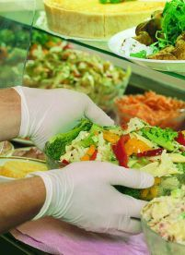
Practices to achieve this include:
- Avoid touching food with the bare hands – use tongs, a spatula, fork, serving spoon or gloves when touching food especially food that will not be further cooked or processed
- Avoid touching food surfaces with the bare hands – this means avoiding touching preparation benches, preparation equipment and the food contact surfaces of serving items such as plates, bowls and cups with the bare hands
- No jewellery to be worn on hands and wrists – food can lodge in the jewellery, deteriorate and then fall back into food. There is also a chance stones/gems may fall out from rings and jewellery into the food providing a physical contaminant. If you simply must wear a ring, then cover it using a coloured band-aid and disposable glove
- Facial hair must be kept neat and controlled – hair should either be covered or sprayed to keep it controlled in such a way that hairs do not fall into food. Long hair must be tied back, and beards should also be covered. In kitchens and food areas, hair nets or hats should be worn
- Fingernails must be short, clean and free of polish (including clear nail polish) –cracked fingernails and chipped nail polish can harbour bacteria and may also flake off into food. Fingernail decorations and artificial nails are also prohibited

- Clothing must be clean – a minimum requirement is for clean clothes for each shift with further changes as spillages and 'working dirt' dictate. You are not permitted to wear ‘food handling’ clothes to and from work
- Cuts and sores must always be covered – a coloured, water-proof dressing must be applied and a finger stall also used where necessary. A disposable glove can also be worn where the cut or sore is on the hands
- Food handlers in the acute state of a common cold must not handle uncovered food – but they may, for example, work where food is in sealed containers, such as in a bottle shop or a retail shop where all food sold is in tins or sealed packets
- Food handlers with any communicable disease must not deal with food until they receive a certificate from a doctor stating as a food handler they are cleared to work with food – see Section 3.2 for more detail.

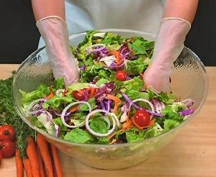
Disposable gloves
The use of protective, disposable gloves in food handling is an excellent safe food handling practice but gloves do not/cannot fix all food hygiene problems.
When wearing/using disposable gloves:
- Change gloves immediately they are ripped/torn – do not continue working while wearing torn gloves
- Change gloves between handling raw and cooked, ready-to-eat foods – to avoid cross contamination (such as the transfer of bacteria from raw food/blood to cooked, ready-to-eat foods)
- Change gloves every hour regardless – you cannot wear the same pair of gloves for longer than this, or for an entire shift
- If handling money do not use the same gloved hand to handle food – take one glove off, handle the money with that hand (without the glove on), and then put on a new/clean glove before returning to food handling duties
- If changing gloves during service, ensure they are not taken off over food/food surfaces – if the gloves contain powder, this may fall out onto food or food preparation surfaces and provide a source of contamination
- Do not try to put on gloves that have already been used – disposable gloves must be disposed off/thrown out as soon as they are taken off
- Do not turn gloves inside out and try to wear them again – see above
- Change gloves whenever they become contaminated from whatever source – raw food, blood, sneezing, chemicals, scratching the face, handling rubbish.

Clothing, personal protective clothing, bandages and dressings
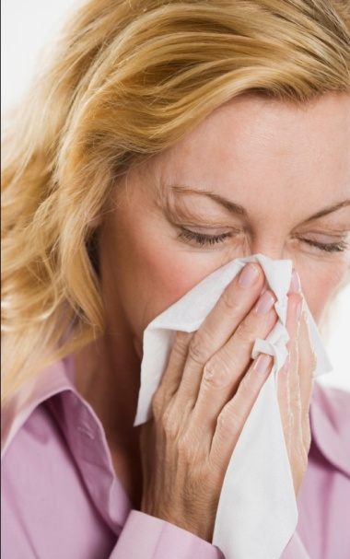
Dirty clothes and infected cuts and sores all pose a food risk.
You must:
- Ensure anything from your body or anything you wear does not contaminate food or food surfaces. Practical measures in this regard include:
- Avoid loose-fitting clothes
- Do not cough or sneeze over food
- Avoid items of jewellery that hang down/dangle
- Avoid wearing rings when working with food – especially avoid (or appropriately cover) rings with stones in them
- Do not wear food handling clothes to and from work
- Remove protective clothing (aprons) when using the toilet
- Take appropriate measures to minimise contact with ready-to-eat food. Practical measures in this regard include:

- Not handling cooked, and/or ready-to-eat food with the bare hands – use tongs
- Handling glasses and cups by their base – and not by the rim
- Handling cutlery by the handles
- Avoiding unnecessary skin contact with food contact surfaces
- Keeping hair tied back – wearing hats or beard nets helps ensure hair does not fall into food
- Avoiding touching hair while working with food – as this can transfer bacteria
- Keeping fingernails short – to avoid physical contamination from the nail (and to make them easier to clean)
- Wearing disposable gloves when handling food – and changing them regularly/as required
- Avoiding nail polish, fingernail decorations and artificial fingernails
- Wear clean clothing when handling food. Practical measures in this regard include:
- Wear clean clothes to work daily
- Have a change of clothes available at work – to change into if one set of clothes becomes dirty/contaminated
- Wear protective clothing such as aprons
- Use waterproof bandages and dressing on exposed parts of the body where there are cuts and/or sores when handling food. Practical measures in this regard include:
- Wear only coloured band-aids when handling food – they are easier to identify if they fall into food
- Wear a finger stall over a bandage/dressing on a finger – to give extra protection and security
- Wear a disposable glove over a bandaid, dressing or bandage that is on the hand.

Identifying and reporting unsafe food handling practices
You are obliged to be constantly alert to the possibility of unsafe food handling practices occurring in your workplace so you can report them in order that appropriate corrective action can be taken.
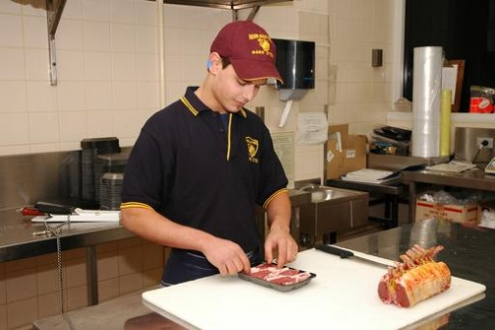
How would you identify non-compliant practices?
The three main ways to identify problems in the workplace in relation to food safety are:
- Personal observation of conditions and/or staff practice
- Inspection of raw materials, premises, equipment and final products
- Review of food safety records.
How should/could these ‘out of control’ situations be reported?
Speed is important in responding to and reporting inconsistencies and ‘out of control’ situations so the recommended methods of reporting are:
- Face-to-face
- Verbally, over the phone.
Reports should be made to:
- Management
- Relevant staff – who are involved in the problem, or will be involved in fixing the problem
- Customers – only where a recall of food has been decided as being necessary
- Local health authorities – only where a food recall has been implemented.
When these reports are made, consideration should be given to covering the following:
- Identifying the food involved
- Naming the people involved – staff and customers (where appropriate)
- Reporting any action already taken to limit the potential negative impacts
- Recommending action for limiting the future potential negative impacts
- Identifying (if known) what caused the out of control situation
- Describing what you think could/should be done to prevent a recurrence of the problem.
Note, however, the most important thing is to take appropriate immediate action to prevent food poisoning – discussions about what needs to be done in the future should wait until after the on-the-spot remedial action to retrieve the situation has been taken.

1.4 Receive, handle and store all food items according to enterprise standards and legislated requirements

Introduction
At all stages of food handling there is a need to observe and apply relevant safe food handling procedures.
This Section addresses requirements as they apply to the receival of food into the premises from suppliers, the general handling of food items and the storage of food.

Receiving food
You may be responsible for receiving food into the premises.
This means accepting food from suppliers that has been ordered by management and chefs.
All food (without exception) must be inspected on arrival at the premises – no food must ever be accepted, signed for or paid for until it has been properly inspected.
From a food safety perspective where food fails to meet the following criteria, it must be rejected (that is, you must refuse the delivery and get the delivery driver to take it back to the supplier).
The safe food handling requirements in relation to food receipt are:
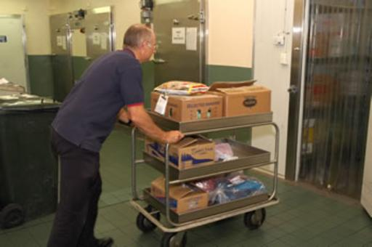
- Inspect the deliveries – you should conduct a visual inspection of deliveries to make sure:
- The food is free from visible contamination – for example, frozen food must be hard frozen; packaging and wrapping must not be torn; the integrity of tins and packets has not been compromised and they are not leaking; the food was not delivered amongst chemicals; the food does not smell ‘off’; cans are not ‘blown’
- The delivery does not bring in pests or rodents – spiders, cockroaches, mice
- The use-by dates of the food are acceptable – reject any food delivered beyond its use-by date or where you believe it will not be able to be used before it reaches its use-by date
- Compare the food delivered to any product specifications set for food items – not all establishments will have these specifications in place but where they are being used, they should be checked. If the food delivered does not meet specifications it must be rejected
- Inspect the food delivery vehicle – check it is clean (see definition below) and is a dedicated food delivery vehicle. Food should not be delivered to food premises in private vehicles – dedicated food transport vehicles should be used
- Check the practices of the delivery driver – check things such as:
- Whether or not food is protected during the delivery process – is the delivery vehicle left unlocked during deliveries? Is food placed on the footpath? Are there chemicals mixed in amongst the food items?
- Personal hygiene of the delivery driver
- Check the temperature of the food is in accordance with the following using a properly calibrated thermometer:
- Frozen food should be hard frozen with no evidence of defrosting: - 15°C is the recommended temperature
- Hot food that is ‘potentially hazardous’ must be at 60°C or above
- Potentially hazardous refrigerated food must be at 5°C or below
Note: potentially hazardous food may be accepted where the delivery driver can prove to your satisfaction the combination of time and temperature have not adversely impacted on food safety.
In general terms, if the food has been in the Temperature Danger Zone for 2 hours or longer the food should be rejected.
When accepting a delivery of potentially hazardous food in the Temperature Danger Zone, it should be used first/immediately and not be subject to the standard stock rotation principle of First In, First Out
- Check all packaged food is properly labelled with the name of the supplier, manufacturer or vendor – all food delivered into a food premises must be able to be identified to assist with food recalls and to help identify the source of problems/contamination where an outbreak of food poisoning occurs
- Store all deliveries as soon as possible after they have been delivered and checked – never leave refrigerated or frozen food lying around in the receival area as their temperature will quickly rise.

Handling food
‘Food handling’ is any activity that involves the handling of food (including preparing, cooking, thawing, serving, displaying food), so it is important these notes are read in conjunction with other food safety information provided.
General requirements in relation to maintaining the safety of food while it is being handled, processed or prepared include:
- Ensuring only safe and suitable food is processed – food unfit for consumption must not be processed. This includes foods that:
- Looks or smells ‘off’
- Shows other signs of contamination
- Exceeds its use-by date, or food taken from a source where the integrity of the packaging has been compromised
- Protecting food being prepared from contamination – this includes preventing contamination from:
- Physical sources – such as hairs, broken glass, dead flies, dirt, dust, airborne contamination
- Chemicals – such as fly spray or the introduction of cleaning chemicals into the food
- Microbiological contamination – which may be caused by leaving potentially hazardous food in the Temperature Danger Zone for too long while it is being processed, or failing to cook food at the correct temperature.
High risk food should reach an internal temperature of 75°C which should be verified with a thermometer
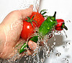
- Ensuring all fruit and vegetables are washed in a sanitising solution before being prepared
- Excluding unhealthy people from food handling/processing activities
- Using clean equipment and utensils that have also been sanitised and are in proper working order – any piece of food equipment not working properly either raises OHS risks for staff or presents the possibility the food processing job it was intended to do (such as to cook food to a certain temperature, or store/display food at a certain temperature) may not be achieved thereby introducing the potential for food poisoning
- Ensuring chemicals are kept separated from food and food utensils and equipment during processing – it is a requirement that all chemicals are stored separately from food
- Keeping individual batches of processed food separate – batches of prepared food should never be mixed together (e.g. in a bain marie) as this can give rise to situations where food may remain able to be served even though it has passed its safe food date/time. Mixing batches of food also causes problems if an internal food recall is needed
- Avoiding touching food with the bare hands where that food will not be subsequently cooked – it is best practice to wear disposable gloves or to use utensils to handle all food
- Using colour-coded chopping boards to reduce the likelihood of cross contamination. For examples the following colours for boards could be used as follows:
- White – for dairy products only
- Red – for raw meat only
- Blue – for seafood only
- Yellow – for poultry only
- Brown – for cooked meat only

- Green – for fruit and vegetables only
After use all boards should be scraped with a flat metal scraper and washed. Note: Polyboards can be put through the dishwasher and sanitised.
Wooden boards are not the preferred option but if they are used, they should be washed with hot soapy water, rinsed and sanitised.
All chopping boards must be replaced regularly to guard against the problems associated with cross contamination
- Discarding any food dropped on the floor – never use any food after it has been dropped on the floor
- Washing and sanitising any food handling tool, implement or utensil that has been dropped on the floor before re-using it
- Avoiding coughing or sneezing over food or food preparation utensils, equipment or surfaces
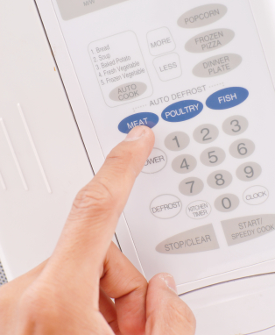
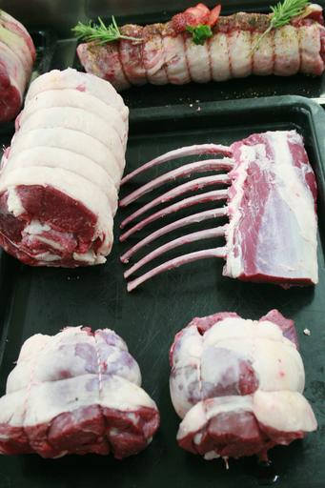
- Using a tasting spoon to taste dishes – never use any utensil to taste food and then replace it in the dish/pot, or use it for stirring.
Thawing food
Frozen food must be thawed before use (also known as ‘defrosting).
There are only three acceptable ways to thaw food:
- In a refrigerator/coolroom – large pieces of meat may take two to three days to defrost so planning ahead is vital: this is the preferred method of thawing as the food is always out of Temperature Danger Zone
- If pressed for time, use a microwave to defrost, moving pieces of food during the procedure – food should be immediately cooked once taken from the microwave after defrosting
- Run the item under cold water (less than 20°C) – only suitable for small portions/items, and unsuitable where the item is breaded/crumbed.
All meats should be cooked immediately after thawing.
It is not acceptable to thaw items out by placing them in a bowl or sink of water.

Storing food
There are three basic storage methods:
- Dry goods storage
- Refrigerated goods storage
- Frozen goods storage.

The standard safe food handling requirements in relation to food storage are:
- Use food grade materials to store food susceptible to contamination – such as stainless steel
- Cover food in storage – to protect it from contamination
- Rotate stock to ensure it is used in the correct sequence – the method used for most food is called ‘First In, First Out’ (see below): any food exceeding its use-by date must be thrown out
- Keep all storage areas and equipment clean
- Never store food (including packaged food) directly on the floor – use shelves
- Ensure pests and rodents are excluded from food storage areas – conduct a regular (at least weekly inspection to check this, and take appropriate action when evidence of pests or rodents is discovered).
Dry goods store
The dry goods store is a non-refrigerated store where canned and dried food is kept. It may be room-size, a variety of cupboards and/or a pantry. Shelves are commonly used to store dry food goods.
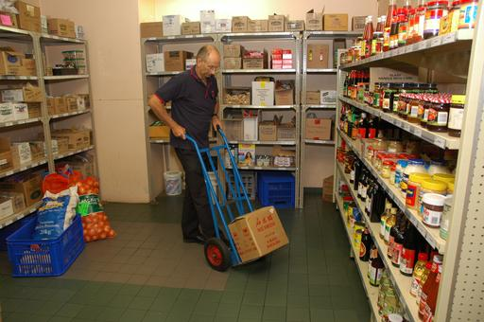
Ensure:
- The area is fly- and vermin-proof – to minimise contamination by pests
- It is well ventilated and lit – to deter pests and to allow staff to see what they are doing and identify and remedy spillages and vermin
- It is never overstocked – excess stock costs money, clutters things up, and increases the chance of out-of-date stock
- It is fitted with doors making a proper fit when fully closed – to help exclude pests
- The lowest shelf is sufficiently far enough above floor level to enable air circulation around goods, and allow mops and brooms to get under the shelves when cleaning is required
- Bulk food containers are made from food grade materials and have tight-fitting lids – plastic garbage bins are not permitted to be used for food storage as they are liable to splitting, do not have a smooth internal surface to facilitate cleaning and do not protect sufficiently against mice and rats
- Food storage containers are cleaned and sanitised before being re-used/re-filled – to guard against batch-mixing
- Any canned, tinned or bottled food must be transferred to an appropriate container and refrigerated once the container has been opened – it is not acceptable (for example) to open a can, use half the contents and then return the open can to dry storage. The food must be transferred to a plastic or stainless steel (or other appropriate) container and then placed in the refrigerator.

Refrigerated goods store
Refrigerated storage is used for fruit and vegetables, dairy products, meat and all other potentially hazardous foods.
Refrigerated storage may occur using coolrooms, under-counter refrigeration units or domestic refrigerators.
Ensure:
- The temperature is kept at 5°C or below and is checked with an independent calibrated thermometer – checks must be done at least once per day
- The maximum time high risk foods should be stored at 5°C or below is 7 days. Foods should be eaten within this time or discarded. Where the temperature is 3°C or less, this time could extend beyond 7 days
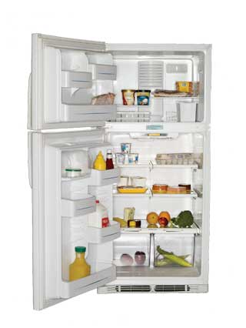
- The coolroom/refrigerator door is closed between uses and an effort made to minimise opening times by planning openings – an open door raises the temperature and makes the unit more expensive to operate
- The cool room is not overcrowded – to enable air to circulate freely around food items
- Food loads put into the coolroom/refrigerator are broken down into smaller units to enable faster cooling – where large units of food are placed in the refrigerator it takes a lot longer for the core of the food to move out of the Temperature Danger Zone.
Hot foods should be allowed to cool (for example, by placing the food in pots and then into tubs full of a water-ice mixture) before being placed in the cool room. Frequent stirring of the food will help it to cool quicker.
The ‘Two-step rule’ for cooling hot foods must be complied with – see next Section
- All food is covered and protected from contamination – plastic film with a label attached to identify the food and date it was placed under refrigeration should be used
- Potentially hazardous raw food is separated from cooked and/or ready-to-eat foods – this is to prevent cross contamination
- Never store potentially hazardous raw food above cooked and/or ready-to-eat foods as there is the potential for raw blood or juice to drip down onto the food below.
Frozen storage
Freezers are used to store frozen produce.
Freezers may be chest type, up-right, or walk-in, but they must be maintained such that the food remains hard frozen (recommended temperature is -15°C or below: many operate at -18°C).
Every time the freezer is used, it should be standard practice to visually check the temperature gauge and notify management where there is a problem – do not overload freezers as it takes too long for the middle of products to freeze.

Ensure:
- Hot food is never frozen – cool it first following the two-step rule for cooling hot food (see Section 1.5)
- Thawed items must never be refrozen – once de-frosted, food should be used or thrown out
- Freezers are defrosted regularly – to maintain operating effectiveness and encourage turnover of items
- Freezer doors are kept closed when the freezer is not in use – to keep cold air in
- Freezer temperature is be checked at least daily – to ensure correct operating temperature
- Large pieces/amounts of food are not frozen as this encourages others to defrost the item and then re-freeze it – in practice this means freezing slices of meat rather than slabs of meat, and using shallow storage containers rather than deep ones to freeze food
- Manufacturer’s instructions regarding the storage of frozen food products are followed – these may relate to storage temperatures and the length of time the product can be stored (for quality and/or safety reasons).
First In, First Out stock rotation
Effective stock rotation for foods means using the FIFO approach to stock rotation – First In, First Out.
This method requires food to be used/served in the order it was delivered meaning the foods in stock the longest are used first.
In practice this means when storing food:
- Old/existing stock must be moved forward on the shelf and the newly delivered stock must be placed behind it – this allows the stock at the front (the oldest stock) to be used before the newer stock
- Existing product in a chest freezer should be removed and the new stock placed at the bottom of the freezer – the existing/old stock is then replaced in the freezer on top of the newer stock
- Check use-by dates of products – and store them so the nearest date is at the front so it will be used first.
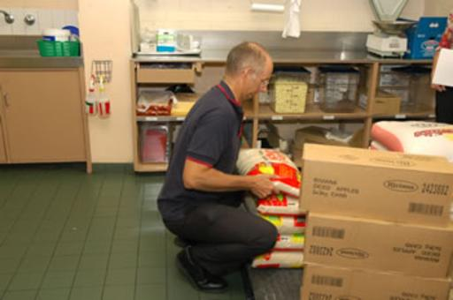

1.5 Prepare, serve and store food in compliance with enterprise standards and legislated requirements

Introduction
The previous Section discussed several basic requirements relating to the preparation of food.
Those requirements apply across all food handling stages including the service and storage of food.
This Section presents additional food handling/food preparation protocols plus requirements for the service of food to customers and for the display of food for sale and/or service.
In the context of the notes for this Section, ‘storage’ refers to the hot and/cold display of food for sale or service as opposed to traditional dry goods storage, refrigerated storage and frozen storage covered in the previous Section.

More food preparation and handling protocols
Two-step rule for cooling hot food
The two-step rule provides explicit direction for the cooling of high risk, hot food.
It states:
Step 1: Cool hot food down from 60°C to 21°C within 2 hours of removing the food from the stove, oven or other cooking unit.
Step 2: Once the food has reached 21°C it should be placed into a refrigerator/cool room, and then cooled to 5°C (or below) within a further 4 hours.
If the cooling of high risk food does not meet these criteria, the food must be thrown out to optimise food safety.
Once the food has reached 5°C, it can safely be put in the freezer.
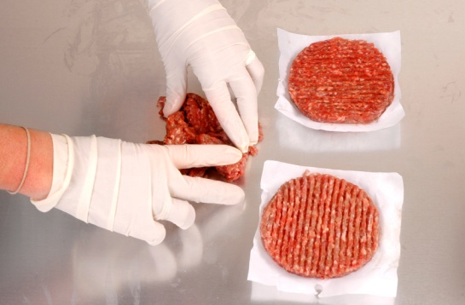
Cross contamination
Cross contamination is the contamination of food (or food preparation surfaces, equipment, utensils) with bacteria, chemicals or allergens as a result of contact with a contaminated source.
Bacteria cannot fly, jump or hop so they depend on people to move them around from place to place via direct contact or through indirect contact.

Examples of direct contact are:
- Using a knife to cut raw meat and then using the same knife to cut cooked, ready-to-eat meat without cleaning and sanitising the knife in between tasks – the blood and residual meat on the knife will carry bacteria and this will be transferred by the knife to the previously safe cooked, ready-to-eat meat
- Using a chopping board to cut raw chicken and then using the same chopping board to cut cooked meat for salads without cleaning and sanitising the board in between tasks – the chopping board will carry bacteria from the uncooked chicken (the cooking process should destroy the bacteria) which will then be transferred to the previously safe to eat cooked meat.
Examples of indirect contact are:
- Coughing or sneezing into your hand, and then using your hand to prepare/touch food or to touch a food preparation surface without first washing it to remove the contaminants.
The primary causes of cross contamination are:
- Linen items (uniforms, tea towels, towels, swabs, handkerchiefs, cloths) that are contaminated with human waste such as blood and secretions, and food residue (such as food that has been wiped up after a spillage or in order to clean a plate for presentation purposes)
- Dirty equipment – which is used to process, hold or serve food
- Dirty utensils – which is used to serve or eat food
- Raw food making contact with cooked/ready-to-eat food or surfaces that will be used to prepare or serve cooked/ready-to-eat food
- Failure of food handlers to wash their hands when and as required.
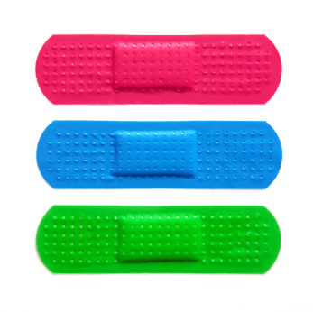
Ways to prevent cross contamination
The following techniques will help reduce the likelihood of cross contamination:
- Wearing clean clothes and clean protective clothing for each shift
- Cleaning and sanitising food equipment, utensils and preparation areas in accordance with the cleaning schedule for the premises – including cleaning and sanitising of preparation benches in between preparing raw high risk food and other foods
- Using waterproof bandages and dressings on cuts and sores
- Washing – and properly drying – hands when and as required
- Storing cooked, ready-to-eat food above raw high risk foods
- Separating the storage of raw and cooked/ready-to-eat foods
- Keeping foods covered as much as possible when in storage, while being processed and displayed

- Using separate sinks for washing ready-to-eat salad vegetables/vegetables and other high risk foods – this includes a requirement a sink used for thawing high risk foods by running it under cold water should take place in a different sink to the one used for washing salad vegetables/vegetables

- Allocating different food handlers to raw foods and cooked/ready-to-eat foods
- Storing chemicals separately from food items
- Not wearing food handling clothes to and from work
- Using disposable towels instead of cloth towels
- Changing disposable gloves whenever there would be a need to wash hands – such as in between handling raw high risk food and cooked/ready-to-eat food: gloves should be changed every hour regardless
- Using colour-coded chopping boards
- Not mixing batches of food
- Refraining from tasting food and replacing the spoon back in the pot, tray
- Not coughing or sneezing over food or food preparation equipment, utensils or surfaces
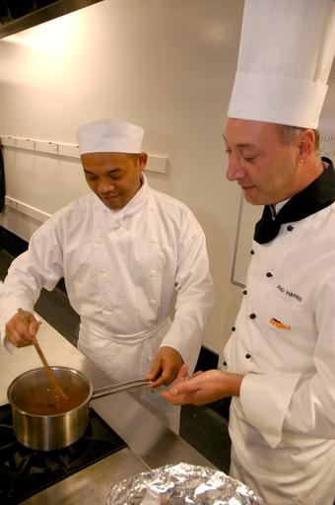
- Cleaning and sanitising knives in between cutting raw high risk foods and cooked/ready-to-eat foods
- Cleaning and sanitising food preparation benches and equipment that are in constant use at least every four hours
- Avoiding the use of equipment and materials - including cleaning materials - between other areas of the premises (such as bathrooms and bedrooms) and the kitchen
- Repairing cracked surfaces in the food preparation area
- Excluding pests and implementing an effective pest control program – which may necessitate the use of a qualified professional external pest control company
- Discarding all food known to be contaminated – or suspected of being contaminated
- Excluding food handlers who are ill from food handling and food-related activities
- Displaying food in such a way it is protected from contamination by customers, especially children – including the use of sneeze guards, monitoring patron actions where self-service food is available and taking appropriate action when the potential for cross contamination is identified
- Disposing of any food dropped on the floor
- Disposing of any food returned from a patron – this includes food and beverage items
- Disposing of any single-use item used once and/or which has become contaminated (or is suspected of being contaminated) for any reason
- Using only food grade equipment to store foodstuffs
- Putting up signs/posters in the workplace to remind food handlers about cross contamination
- Inspecting food deliveries into the premises to ensure they are not contaminated by any visible sources.
Re-heating previously cooked food
It is quite legal to use or to reheat leftovers but there are several safe food hygiene practices to follow in order to do it safely.
Leftovers, or food intentionally cooked beforehand and refrigerated or frozen for later use, are known as ‘previously cooked food’.
The following steps should be followed when reheating previously cooked food, because many instances of food poisoning have been associated with incorrect reheating practices:
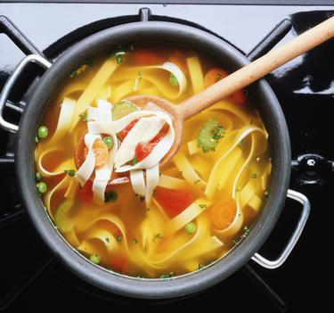
- Food can only be re-heated once – if not used, it must then be thrown out
- Reheat previously cooked food in small quantities, not large – this reduces the time food spends in the Temperature Danger Zone (5°C – 60°C) and helps retain food quality while optimising food safety
- Do not use a bain-marie for reheating – they are only hot holding devices and not designed as heating units
- Food must be protected from contamination while it is being re-heated
- The bain-marie must hold the heated high risk food at a minimum 60°C – so as to be above the Temperature Danger Zone (or The 2/4 Rule must be applied)
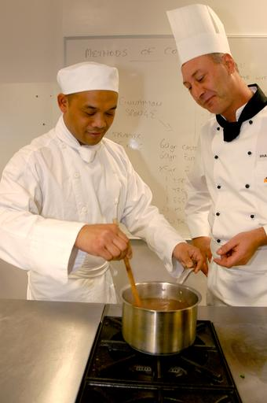
- It is preferable for food to be reheated immediately before service rather than to reheat in bulk and held – again, this optimises food safety and helps maintain the highest food quality
- Stir wet dishes held in the bain-marie regularly to make sure the food does not cool down to below 60°C – this applies even where the units have overhead heating lights
- Previously cooked food, coming from the cool room or a refrigerator to be reheated should be raised to 70°C (for 2 minutes) as soon as possible and then kept at a minimum of 60°C – never leave previously cooked food sitting around in the kitchen on a preparation bench in the Temperature Danger Zone
- A temperature monitoring probe should be used to check the internal temperatures of food that is re-heated – never rely on guesswork, or the visual appearance of the food.

Serving food
Serving of food by staff to customers
The serving of food is an example of ‘food handling’ so all previously mentioned safe food practices must be employed when serving food.

The basic safe food handling procedures for staff when serving hot or cold food (either for on premises or take away consumption) to customers are:
- Potentially hazardous food must be kept out of the Temperature Danger Zone – the temperature of any display units must be taken regularly (at least once per service session) to verify the temperature is correct
- Remember: keep hot food, hot – at 60ºC or above and keep cold food, cold (at 5ºC or below)
- Clean serving utensils must be used
- Never touch food with bare hands – always use disposable gloves, tongs or some other item (greaseproof paper, a fork, a spatula) to create a barrier between the hands and the food in order to prevent cross contamination
- Food must be served into/onto clean plates, bowls or other items (such as single use containers: see below)
- Plates and similar must be stored at the service point in such a way to protect them from contamination – including contamination by flies, dust, customers
- Where food is served into single-use (see below this Section) containers, these containers must be only used once
- All single-use items (food and drink containers, straws, lids) must be stored to protect them against contamination
- Food must be kept protected from contamination – keep doors on display units closed; use lids where provided on storage units
- Staff must apply safe food handling and personal hygiene practices such as:
- Not coughing, sneezing onto food
- Washing hands as required – see later notes
- Using disposable gloves, as required, and changing when required
- Never using food dropped on the floor
- Never using food that has been contaminated in any way
- Use different utensils to serve different food items – to avoid cross contamination (and also to eliminate different foods [or colours] being mixed in with other foods, which is often not wanted by the customer).

Self service of food by customers and service of unpackaged ready-to-eat food
Food may be offered to customers for self-service for consumption on the premises, or for consumption elsewhere/as take-away food.
This can include the provision of self-service salad bars and smorgasbords as well as the ability for customers to serve themselves with bread/rolls, or nuts and confectionery (in a retail outlet).
Providing this option for customers will present a higher level of risk from contamination because many elements of control have been given over to the customer.
It remains a legal responsibility on you to ensure the integrity of food offered in this style of service: if you cannot fully guarantee food safety by allowing the service of food in this manner it should not be offered in this way. Re-consider the service style and use another service/presentation method.
When offering self-service food and unpackaged ready-to-eat food, you must ensure:
- Customer activities are regularly monitored so unsafe practices can be identified and remedial action taken – this means a staff member must be appointed to watch customers in order to prevent them from doing anything to compromise the safety of the food, and to remove food when it has been contaminated
- Special attention is paid to children at self-serve areas – they are prone to handling food with their hands as well as taking food and then putting it back
- Hot food is kept hot (60°C and above), and cold food is kept cold (5°C and below)
- Any utensils dropped by customers are immediately replaced with clean and sanitised ones
- Spills are cleaned up immediately
- Any contaminated food is thrown out – this includes contamination caused by customers coughing or sneezing over the food
- Signs are posted advising customers of safe food handling practices – such as asking them:
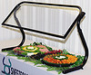
- Not to use utensils in other foods
- To refrain from coughing and sneezing over the food
- To refrain from handling any of the food with their bare hands
- To supervise children
- Foods are covered and protected from contamination when not actually being used
- Separate utensils are provided for each food item
- Sneeze-guards are in place
- Batches and/or trays of food items are not mixed – stock rotation is important but so is the need to keep batches separate
- Throw out any plate waste/returned food
- Small batches of food are put on the smorgasbord – and replaced frequently, rather than putting out large trays or large amounts of food to begin with
- Extra utensils are provided – there always seems to be a need for more service spoons and forks
- Clean ‘rests’ for utensils (service spoons and forks) are provided and changed regularly to prevent cross-contamination
- The 2/4 rule is being complied with.
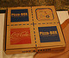
Single-use items
A single-use item is something intended to be used once in relation to food and then disposed of.
Single-use items must not be re-used even if they are cleaned in between uses.
Examples of single-use items include:

- Take away food and drink containers – including pizza boxes, coffee cups, boxes for hamburgers, packaging for rolls and sandwiches
- Drinking straws
- Disposable gloves
- Plastic cutlery
- Food wrappers – around items such as hamburgers and other take away menu items.
What requirements apply to single-use items?
Single-use items:
- Must not be used more than once by the business – customers are free to re-use them at home as they see fit: customers may also re-fill single-use cups themselves from drink dispensing machines.
Note: single-use containers may, however, be used by the business for non-food activities – such as collecting or storing dirty cutlery
- Must be stored and/or displayed so as to be protected from contamination – this contamination may be via:
- Flies, pests and vermin
- An infected food handler
- Airborne contamination
- Physical contamination
- Customers
- Must not be used if they have been contaminated – or there is suspicion they may have been contaminated: this can include:
- Disposing of any single-use items handled by customers
- Disposing of any single-use items dropped on the floor
- Disposing of any single-use items where the protective packaging they were delivered in has been compromised
- Must be clean in order for them to be safely used – meaning free from visible contamination of any sort (including food).

Practical measures
Practical measures to optimise safety when using single use items include:
- Not preparing pizza boxes in advance and leaving them ‘open’ – this allows airborne and other contamination to settle inside the boxes on the food contact area: pizza boxes should be constructed ‘to order’, when required
- Providing drinking straws in containers allowing only one straw at a time to be dispensed without others in the container being touched: an alternative is to only use individually wrapped drinking straws
- Storing take away food containers (for food and beverages) upside down – so the food contact surface of the container is not exposed
- Storing the lids to take away containers safely – so the side making contact with the drink/food is protected
- Disposable cutlery should be kept covered or individually wrapped
- Toothpicks should be individually wrapped.

Displaying food
Any food (apart from fresh fruit) displayed on a service counter must be wrapped to protect it from contamination.
It is best to use display cabinets to display food for sale/service.
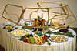
Display cabinets can be either hot or cold.
Cold food cabinets
When using cold food display cabinets:
- Potentially hazardous food should be at or below 5°C
- Food should be covered/wrapped to prevent contamination
- Temperatures must be regularly checked (at least daily – once every session, or every four hours is preferable) using an independent, properly calibrated thermometer
- Protective guards (‘sneeze guards’) must be provided (where appropriate) to prevent customers breathing, sneezing or coughing over the food
- Pre-prepared sandwiches and pre-filled rolls should be stored in these cabinets – where they are not so stored, some system must apply (such as the use of colour-coded stick-on labels, or written times on the wrapping/container) to provide control over the length of time the food spends in the Temperature Danger Zone
- Pre-prepared sandwiches and/or filled rolls must not be sold/eaten when they have spent four hours or more in the Temperature Danger Zone.
Frozen food
Where the premises displays frozen food, there is a requirement the food remains ‘hard frozen’ while on display.
This means there must be no visible sign the product has started to thaw.
When using freezers with ‘load lines’, never fill above the load lines as this food will quickly thaw because the required low temperature does not exist above this line.
Hot food cabinets
When using hot food cabinets (which include bain-maries and pie warmers):
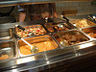
- The temperature of potentially hazardous food must be over 60°C (or the ‘2/4 Rule’ must be applied)
- Food to be put in hot food cabinets must be preheated rapidly before being placed in the cabinet – you cannot use the hot holding unit to heat the food to service temperature. You must pre-heat the food and place it into a pre-heated display unit
- Food should be served in the order it was placed in the cabinet to minimise risk of contamination, as well as guard against loss of taste, appearance and quality
- Hot foods left from the day before should be served first, following the guidelines set out in ‘Re-heating previously cooked food’ – foods can only be re-heated once. Note: some premises have an SOP of discarding all left-over food
- Temperatures of food must be regularly checked (at least daily, preferable each session or every four hours) using an independent thermometer
- Food must not be topped-up but rotated to keep it fresh and avoid mixing batches.

1.6 Clean food-related items, utensils and areas in compliance with enterprise standards and legislated requirements

Introduction
It is important from a food safety perspective and from a customer point-of-view for all food-related items and areas to be cleaned as and when required, and to look clean.
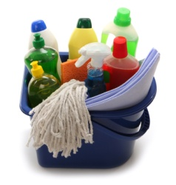
A clean premises with clean equipment and utensils inspires confidence in customers about the safety of the food they are about to eat.
This Section provides relevant definitions and presents a range of necessary cleaning practices.

Chemicals used
Chemicals used in cleaning include:
- Detergents – used to remove dirt and grime from a variety of surfaces and items (cutlery and crockery, pots and pans, kitchen utensils and equipment, floors, walls and ceilings, food preparation surfaces and benches
- Available in different concentrations to meet different cleaning demands, and available to suit different water conditions (hard water and soft water)
- Dilute according to manufacturer’s instructions for the cleaning job being undertaken
- Sanitisers – used to sanitise items (food preparation surfaces, utensils, food equipment and food areas) by eliminating bacteria or reducing the number of bacteria to safe levels
- Make sure you adhere to the nominated ‘contact time’ for the product being used – always use according to manufacturer’s instructions
- Deodorants – used to control smells/bad odours in waste bins
- The use of deodorants is not a substitute for proper cleaning but can be used in the short-term to mask objectionable smells while the cause of the problem is being otherwise addressed
- De-greasers – a chemical designed to cut through grease and fatty deposits. Commonly used in rubbish bins and waste bins to help remove the build-ups present in these containers.

Definitions
Clean
By definition, clean means free from visible debris (dirt, food, grime) and free from objectionable odour.
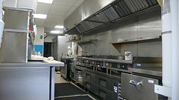
The reference to ‘odour’ is only relevant when the definition is applied to waste/rubbish bins
‘Clean and sanitary condition’
All food preparation equipment and surfaces must be kept in a clean and sanitary condition.
‘Cleaning’ is the removal of visible dirt and debris (including objectionable odour) either from crockery, cutlery, glasses, equipment or fixtures and fittings.
‘Sanitation’ (or ‘sanitising’) is the destruction of microbes. The sanitising process may be achieved by the application of hot water, steam or chemicals, but must be such that it does not allow the transmission of infectious diseases to take place. The use of chemicals is the most common way to sanitise food equipment, utensils, surfaces, areas, crockery, cutlery, pots and pans.
Cleaning is performed before sanitation.
This requirement for items to be clean and sanitary applies to chopping boards, bowls, food storage containers, food display equipment, preparation benches, walls and ceilings and anything in the food preparation, or food service area used to prepare, handle, process, serve, display or otherwise come into contact with food.
It is vital to remember/know an item may be clean (free from visible contamination) but it may not be sanitary/sanitised (free from bacteria).

Need to clean items after every session
It is not sufficient to use, say, a slicer for breakfast, lunch and dinner and clean it just once a day at 9:00PM: it must be cleaned after the breakfast session, after the lunch session and after the dinner session.
It is preferable to clean and sanitise these items at four-hourly intervals but this is not always possible in a working kitchen so ‘after every session’ is the minimum requirement.
Note: enterprise-based requirements may require an item such as a slicer to be cleaned more frequently, for example ‘after each use’, or ‘in between slicing different types of meat’ (such as in between slicing ham and chicken, or in between slicing ham and another type of pressed meat), or ‘every 4 hours’.

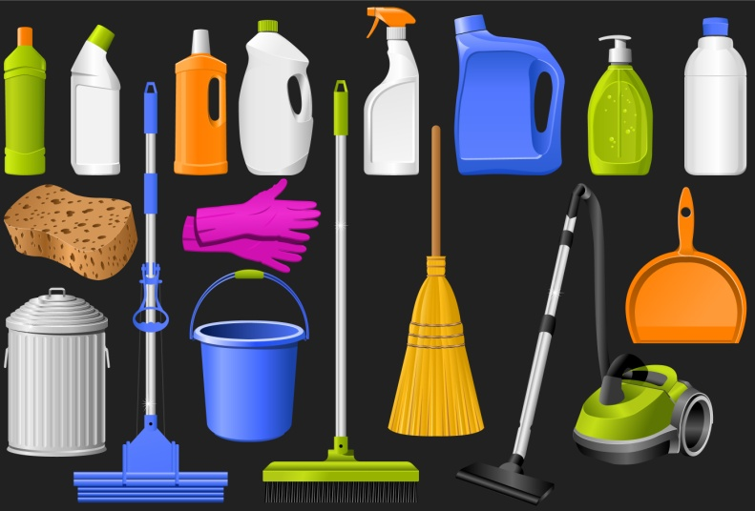
Safety issues
When cleaning:
- Always follow manufacturer’s instructions – in relation to dilution rates, contact time, water temperature and how the chemical is to be applied/used (for example, some chemicals are applied un-diluted; some are mixed with water in a bucket; some are applied using a trigger spray bottle)
- Know where the MSDS are for the chemicals you use – in case there is an accident with the chemical.
These sheets will provide immediate first aid information and other safety information in the case of (for example) a spill, ingesting of the chemical, getting the chemical in your eyes
- Always wear/use the designated safety equipment and/or clothing for the job being undertaken – known as ‘personal protective equipment and clothing’: this may include the use of gauntlets, respirators, face masks, leather aprons and steel-capped boots
- Always wash your hands after using cleaning equipment and/or chemicals.
Storage of cleaning materials and equipment
The following requirements apply to the storage of cleaning chemicals and cleaning equipment:
- Always store chemicals in a designated chemical storage area
- Never store chemicals alongside/near food
- Never store chemicals in food or beverage containers
- Always clean and (where necessary) sanitise cleaning equipment before storing it.

Cleaning practices
Cleaning schedules
All food premises should have cleaning schedules identifying:
- The food-related items and areas that need to be cleaned – by name, or other description of item/area
- When they need to cleaned – giving a time by hour (for example, 10:00AM, 2:00PM and 6:00PM) or general time of day (such as ‘after lunch’)
- By whom they must be cleaned – indicating either a staff member by name, or by job position/title
- What is to be used in the cleaning process – identifying chemicals and cleaning equipment that have to be used
- Detailed cleaning instructions – to explain how each item is to be cleaned: this may include advice on how to dis-assemble an item and re-assemble it after cleaning.
On-the-job training should be provided in how to clean the items/areas you need to clean.
You must adhere to these instructions using the chemicals identified, the cleaning equipment stated and the techniques prescribed at the time/frequency nominated.
Sample cleaning instructions
The following provide generic advice/direction for cleaning of several kitchen items and areas – to convert the following into a cleaning schedule there is a need to add the cleaning chemicals and equipment to be used, and to allocate the cleaning job to a specific staff member.
Please note the following are generic in nature and will need to be changed to accommodate the requirements of specific items where manufacturer’s instructions demand other/additional cleaning requirements.
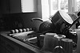
JOB | DESCRIPTION
Kitchen Aid Blender - Daily | Clean the blender and attachments as required during trade and at the end of each day’s trade:  Dismantle as required, rinse with warm water first  Scrape identifiable problem/difficult areas with scraper (soaking where necessary)  Wipe to remove debris  Wash with detergent and hot water, rinse and sanitise  Rinse and allow to air dry.
Bain Marie - Daily | Clean the bain marie at the end of each day’s trade:  Remove bain marie trays and wash them in sink using detergent and hot water, rinse and sanitise  Rinse and allow to air dry  Wash main unit using detergent and hot water, rinse and sanitise  Rinse and allow to air dry.
Microwave ovens - Daily | Clean the microwaves as required during trade and at the end of each day’s trade:  Wipe away loose debris/dirt with a clean cloth  Spot-clean/scrape identifiable problem/difficult areas  Wash with detergent and hot water, rinse and sanitise  Rinse  Allow to air dry.
Coffee Grinder - Daily | Clean the unit at the end of each day’s trade:  Wipe to remove debris  Wash with detergent and hot water, rinse and sanitise  Rinse and allow to air dry.
Cappuccino Machine – Daily | Clean the steam wands as required during trade and at the end of each day’s trade:  Wipe away all debris/milk residue from wands and exterior of machine with a clean cloth  Wash with detergent and hot water, and rinse  Rinse and allow to air dry.
Ovens – Daily | Clean the ovens as required during trade and at the end of each day’s trade:  Heat the ovens  Wipe away loose debris/dirt with a clean cloth.
Rubbish Bins - Daily | Clean the rubbish bins as required during trade and at the end of each day’s trade:  Remove bin liner/rubbish from bin  Wipe away loose debris/dirt with a clean cloth  Scrub interior and exterior of bin with detergent and hot water, rinse and sanitise  Rinse and allow to air dry  Fit with new bin liner.
Sinks (double bowl and pre-wash sinks) & wash hand basin - Daily | Clean the sinks and wash hand basin as required during trade and at the end of each day’s trade:  Wipe away loose debris/dirt with a clean cloth  Wash with detergent and hot water, rinse and sanitise  Rinse and allow to air dry.
Dishwashing machine - Daily | Remove internal filter  Wipe away loose debris with a clean cloth  Wash with detergent and hot water, rinse, sanitise and replace in machine  Remove dishwasher arms  Wash with detergent and hot water, rinse, sanitise and replace in machine  Visually check inside machine and spot-clean any problem areas, and remove any food debris  Hose out tank area.
Utensils, cutting boards and other cooking equipment - Daily | Clean utensils, cutting boards and other cooking equipment as required during trade and at the end of each day’s trade:  Remove dry soil/debris and rinse with warm water  Wash with detergent, soaking as required rinse and sanitise  Rinse and allow to air dry.
Hobart Mixer – Daily | Clean the mixer and attachments as required during trade and at the end of each day’s trade:  Dismantle as required, rinse with warm water first  Scrape identifiable problem/difficult areas with scraper (soaking where necessary)  Wipe to remove debris  Wash with detergent and hot water, rinse and sanitise  Rinse and allow to air dry.
In-Floor Drains - Daily | Clean the in-floor drains at the end of each day’s trade:  Hose out the drains  Remove any visible debris  Add deodorant  Clean the covering grid  Wash with detergent and hot water, rinse and sanitise  Rinse and allow to air dry.
Salamander - Daily | Clean the salamander as required during trade and at the end of each day’s trade:  Warm the salamander and spray with oven cleaner, leaving as per oven cleaner instructions  Wipe to remove debris  Scrape identifiable problem/difficult areas with scraper  Wash with detergent and hot water, rinse and sanitise  Rinse and allow to air dry.
6 Ring Burner - Daily | Clean under the rings as required during trade and at the end of each day’s trade:  Sanitise rings by putting them in Combi oven.
Fryers - Weekly | Clean the fryers as required and at the end of each week:  Drain oil from fryer  Wipe away residual oil  Wash interior and exterior with detergent and hot water, rinse and sanitise  Rinse and allow to air dry  Re-fill with oil.
Oven - Weekly | Clean the ovens as required during trade and at the end of each week:  Heat the ovens  Wipe away loose debris/dirt with a clean cloth  Spot-clean/scrape identifiable problem/difficult areas  Wash with detergent and hot water, rinse and sanitise  Rinse and allow to air dry.
6 Ring Burner – Weekly | Clean under the rings as required during trade and at the end of each week:  Sanitise rings by putting them in Combi oven  Spot-clean/scrape identifiable problem/difficult areas  Clean the trays and surrounding areas with detergent and hot water  Allow to air dry.
Shelves - Weekly | Clean the shelves as required and at the end of each week:  Wipe away loose debris/dirt with a clean cloth  Spot-clean/scrape identifiable problem/difficult areas  Wash with detergent and hot water (soaking where necessary), rinse and sanitise  Rinse and allow to air dry.
Cool Room – Weekly | Clean the cool room as required and at the end of each week:  Remove food from food cool room to freezer (where suitable) as far as can be done and clean inside cool room: limit time any food spends out of refrigeration to no more than 30 minutes  Remove any food matter/debris on floor, walls or shelving  Wash interior, including shelving and seals, and exterior walls with detergent and hot water, rinse and sanitise  Rinse, allow to air dry and replace food.
Display Fridges, Cold Display Unit and Under-Counter Refrigeration – Monthly | In addition to other regular cleaning, clean in and under (where possible) the display fridges/cold display unit as required and at the end of each month:  Remove any food matter/debris  Wash interior, including shelving and seals with detergent and hot water, rinse and sanitise  Rinse and allow to air dry  Clean seals, doors, runners, racking, shelves, drain holes, drip trays and both interior and exterior: use hot water and detergent, rinse and allow to air dry.
Walls - Monthly | - Clean the walls as required and at the end of each month:  Remove visible dirt by spot-cleaning  Rinse and sanitise  Rinse and allow to air dry.
Microwave - Monthly | In addition to other regular cleaning, clean the microwave as required and at the end of each month:  Lift microwave and clean underneath  Wipe and scrub bench under ovens using hot water and detergent  Rinse and sanitise, rinse and allow to air dry.
Ovens - Monthly | In addition to other regular cleaning, clean the ovens as required and at the end of each month:  Heat the oven  Wipe away loose debris/dirt with a clean cloth  Spot-clean/scrape identifiable problem/difficult areas  Spray with oven cleaner and allow to stand as per directions on can/product  Wipe  Wash with detergent and hot water, rinse and sanitise  Rinse and allow to air dry.
Hot Press - Monthly | Clean the hot press at the end of each month:  Remove visible dirt by spot-cleaning  Wash using detergent and hot water  Rinse and sanitise  Rinse and allow to air dry.
Cupboards - Monthly | Clean the cupboards as required and at the end of each month:  Wipe away loose debris/dirt with a clean cloth  Spot-clean/scrape identifiable problem/difficult areas  Wash with detergent and hot water, rinse and sanitise  Rinse and allow to air dry.
Freezers - Monthly | In addition to other regular cleaning, clean in and under the freezers as required and at the end of each month:  Sweep, scrub and mop floor: use hot water and detergent, sanitise, rinse and allow to air dry  Remove food/ice from freezer to cool room and clean inside  Defrost and remove any food matter/debris  Wash interior, including shelving and seals with detergent and hot water, rinse and sanitise  Rinse, allow to air dry and replace food.
Walk-In Freezer – Three Monthly | Clean the freezer as required and at the end of each three months:  Remove food from food freezer to cool room (where suitable) as far as can be done and clean inside the freezer: limit time food spends out of refrigeration to no more than 30 minutes  Remove any food matter/debris on floor, walls or shelving  Wash interior, including shelving and seals, and exterior walls with detergent and hot water, rinse and sanitise  Rinse, allow to air dry and replace food.
Ceilings and light fittings – Three monthly | Clean the ceilings and light fittings as required and at the end of each three months:  Remove visible dirt by spot-cleaning  Wash ceilings and light fittings using detergent and hot water  Rinse and sanitise  Rinse and allow to air dry.
Exhaust Canopy and Filters | Exhaust canopy and filters are cleaned by Contract Cleaner:  Canopy cleaned every 6 months  Filters cleaned every month.

General cleaning requirements
All businesses are required to keep their food premises and equipment clean meaning there must be no build up of dirt, food or other material.
The business must also maintain all its fixtures, fittings and equipment (including storage areas) in a clean condition.
This requirement applies to things such as walls, floors, ceilings, windows, benches, shelves, sinks, wash hand basins, cupboards, grease filters, cooking equipment, food preparation equipment, food utensils, food vending machines, light fittings, ventilation ducts, pipes and electrical wiring.
It is also a requirement the equipment used to do the cleaning (brooms, mops and buckets, hoses) must also be cleaned – they should be cleaned, washed and/or sanitised after each use.
Cleaning and sanitising of eating utensils by hand
All service gear (such as plates, cups, saucers, glasses, cutlery) must be cleaned and sanitised after each use in order to help prevent food poisoning.
After these items have been cleaned and sanitised they must be stored so they do not become re-contaminated: the requirement is all items used to serve food and beverages are provided to the customer in a clean condition.
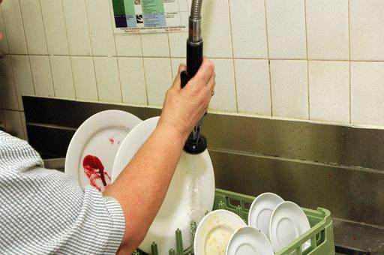
In general terms, the following seven-step sequence is suitable for cleaning/washing crockery and cutlery:
- Remove visible food debris – for example, scrape the plates
- Rinse with warm water – to remove loose dirt and loosen other dirt
- Wash with a detergent – to remove remaining dirt/food debris
- Rinse again – to remove the detergent and debris
- Apply a sanitiser – to kill bacteria: very hot water may also achieve the same result
- Rinse – to remove the sanitiser (if recommended by manufacturer of the sanitiser)
- Allow to air dry.
Air drying is the preferred option as it eliminates using a cloth to dry surfaces, which may inadvertently introduce bacteria to the surface that has just been cleaned and sanitised.
Machine washing of plates and cutlery
The procedure for washing eating utensils and dishes by machine is as follows:
- Scrape and rinse items prior to stacking in trays – use the right trays/racks for the right items. There are different trays/racks for plates, cups, cutlery.
- Wash for a minimum of 60 seconds at a temperature between 66°C and 71°C
- Rinse for a minimum of 10 seconds at a temperature of at least 77°C
- Allow to air dry.

Using a double bowl sink to wash crockery and cutlery
In some circumstances there will be no dishwashing machine: this is common in small businesses and it is possible to safely and effectively use a double bowl sink to properly wash crockery and cutlery providing certain requirements are observed.
When using a double bowl sink to wash eating utensils and dishes:
- One bowl must contain water at 45°C and detergent – for washing
- One bowl must contain clean water at a minimum of 77°C – for sanitising
- Sanitising must involve soaking the items for a minimum of 30 seconds – it is not acceptable to just run hot water over items to remove the suds
- A thermometer must be on hand to check water achieves the required temperatures as identified.
Items must once again be left to air dry.
Cleaning of bar equipment
When working in a bar serving alcoholic and/or non-alcoholic drinks you need to pay attention to safe food handling practices, including cleaning, in the same way other food handling staff do.
Working behind a bar can involve:
- Cleaning of small equipment such as drip trays (including those provided under beer taps, under post mix nozzles, and those inside refrigerated equipment), chopping boards, knives, spoons, glassware, cocktail shakers and measures
- Cleaning of large equipment such as refrigerators – with special attention to the seals around doors which can become sticky due to dripping drinks being passed over them. Large bar equipment also includes ice machines and glass chillers
- Cleaning of beer lines – where beer is dispensed from kegs using beverage/beer dispense lines, these should be cleaned at least weekly according to brewery instructions using only chemicals approved by the brewery: in hot weather beer delivery lines should be cleaned twice a week
- Cleaning of fixed items – such as the bar counter, cash registers and mirrors: these are not really related to ‘food safety’ as such but they help give the bar the appropriate ‘clean’ look customers want.

Work Projects
It is a requirement of this Unit you complete Work Projects as advised by your Trainer. You must submit documentation, suitable evidence or other relevant proof of completion of the project to your Trainer by the agreed date.
1.1 For the workplace where you work as a food handler, prepare and submit a list of:
- The safe food handling/food safety legislation you must comply with in terms of safe operating practices including personal hygiene, personal activities and personal health – by name of the legislation, regulations or Code
- The enterprise-specific requirements (policies, procedures and/or internal safe food handling systems) you must adhere to – listing each requirement individually.
1.2. Prepare five posters or checklists suitable for use in your workplace to assist other staff in safe food handling practices in relation to:
- Receipt of food into the premises
- Handling/preparation of food
- Storage of food
- Service of food to customers
- Display of food for sale/service.
1.3. Identify one piece of food preparation equipment used in your workplace and prepare a comprehensive set of cleaning instructions for this item, ensuring coverage of:
- When the item is to be cleaned
- How it is to be cleaned, listing all necessary steps and processes to ensure the item is properly cleaned and sanitised
- Chemicals to be used to clean and sanitise the item – naming each chemical by type and brand name and describing dilution rates, contact time (where appropriate) and how the chemical is to be applied
- Cleaning equipment to be used in the cleaning process.

Summary

Follow hygiene procedures
When following hygiene procedures:
Identify all legislated and workplace safe food handling requirements
Never be afraid to ask for advice or direction about what needs to be done
Complete all necessary workplace documents to reflect and record safe food handling activities
Take special care when handling potentially hazardous/high risk foods
Minimise the time high risk food spends in the Temperature Danger Zone
Use a properly calibrated probe food thermometer to test the temperature of food and food appliances
Realise safe food handling practices apply to beverages as well as food
Implement required personal hygiene practices and standards
Avoid contact with the bare hands with prepared/ready-to-eat food
Be constantly alert to the potential for unsafe food handling practices and take appropriate action (or report them) when identified
Only buy food from approved sources/businesses
Check all incoming food to ensure it is safe
Store all food according to its individual requirements
Rotate food using FIFO stock rotation principles
Handle food to protect it from contamination
Discard all out-of-date stock
Never thaw foods by placing them into sinks/bowls of water
Always observe the two-step rule for cooling hot food
Be alert to the potential for cross contamination and guard against it
Only re-heat previously cooked food once and re-heat it to 70°C for 2 minutes
Supervise the self-service of food by customers to themselves
Keep hot food hot (60°C and above) and cold food cold (5°C and below) when it is displayed for sale/service
Ensure service items (including single-use items) are clean
Only use single-use items once
Follow designated cleaning schedules and instructions when cleaning food surfaces, items, utensils, equipment and areas
Clean all food equipment and surfaces after every session, or every four hours
Use detergent and a sanitiser to clean food items, surfaces, equipment, crockery and cutlery.

Element 2:
Identify and prevent hygiene risks

2.1 Identify potential food, personal, environmental and other risks in the workplace promptly

Introduction
Food handling staff must always be alert to the possibility of any risks posed by hygiene hazards in the workplace creating a threat to the safety of food.
This Section identifies food, personal, environmental and other risks to be aware of.

What is a food hazard?
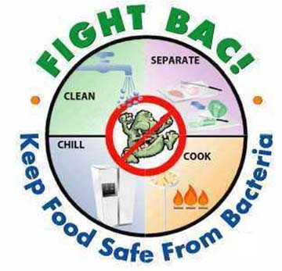
A food hazard may be seen as any micro-biological, chemical or physical contaminant in food.
Four keys in responding to these threats are:
- Awareness
- Constant vigilance
- Immediate reporting
- Quick and effective responses.

Microbiological contamination
Microbiological contamination is caused by bacteria, moulds, and viruses via intoxication or infection.
Bacteria
These are single-celled life forms and are found everywhere.
They are found in the air, soil, on our hands, equipment and utensils. Bacteria live in both humans and animals, growing and multiplying rapidly, aided by warmth, moisture, time, food and oxygen. They are so small that several million can fit onto a pinhead.
Bacteria reproduce rapidly and the average bacteria take about 10 to 20 minutes to reproduce. If the environment is favourable, bacteria can grow from 1 to over 2 million bacteria in the space of 7 hours.
Bacteria favour high temperatures, and multiply rapidly when the temperature is high. The Temperature Danger Zone in which bacteria will multiply rapidly is between 5ºC to 60ºC.
Bacteria multiply rapidly but words cannot tell the full story. Consider the following scenario based on just one single bacterium which divides (via ‘binary fission’) every 20 minutes, and see how the numbers explode.
TIME | BACTERIA NUMBERS
9.00 | 1
9.20 | 2
9.40 | 4
10.00 | 8
10.20 | 16
10.40 | 32
11.00 | 64
12.00 | 512
1.00 | 4,096
2.00 | 32,768
5.00 | 1,677,216
Problem bacteria include (but are in no way limited to):
- Clostridium perfringens – usually caused when food is cooked, chilled overnight and re-heated, or found in foods that are cooked 'rare'
- The initial source of the contamination is faeces (man, birds, animal or insects) which is introduced somewhere along the food chain/production line (failure of staff to wash their hands after the toilet; flies carrying it onto food; contamination at the abattoir)
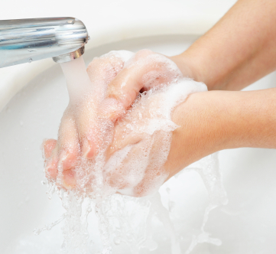
- Salmonella – a very common contaminant
- Faecal contamination is a prime source (failure of staff to wash hands after the toilet; flies carrying it onto foods; leaky plumbing; fish harvested from waters polluted by sewage)
- Streptococci – caused by nasal or oral discharges into food (coughing, sneezing), either directly or via hands that have been so contaminated
- Staphylococcus aureus – a rapidly acting bacteria where the main source is the food handler: nose, throat, mouth, skin, pimples and cuts, either via direct or indirect contamination
- Clostridium botulinum – a rare bacteria but a very lethal contaminant (with a 65% mortality rate).
Can occur when heat processing of tins and jars is incomplete allowing hardy spores (see below) to survive and cause the problem.
Any tin that 'spurts' when opened, is leaky or is 'blown', or jars with broken seals must be discarded as this is a sign of botulism contamination: there is no adverse smell and food must not be tasted to test it as the small amount ingested during tasting can kill.
Note: there is usually no sign food has been infected by bacteria. It will not always/necessarily look, smell or taste different to food that is not infected/contaminated be bacteria.
Spores
Some bacteria can survive in harsh environments by changing into spores.
The spores have a thick coat which makes them very tough and difficult to kill.
When bacteria form into spores, they can re-form back into bacteria when conditions return to being favourable: the spores are resting, not growing – they are simply waiting for ideal growth conditions to return and they begin multiplying again.
Fortunately, not all bacteria form spores because spores may not be killed by normal cooking.

Spores can be stopped from becoming active bacteria by:
- Keeping food above 60ºC
- Keeping food below 5ºC
- Keeping dry food, dry
- Cooling hot foods quickly through the Temperature Danger Zone, rather than just allowing them to cool for long periods at kitchen temperatures.
Moulds
Moulds can be harmful or useful to food. Certain moulds damage the food on which they grow. In some cases moulds can be very dangerous if they are eaten by humans.
Other moulds are used to enhance food, for example those used in cheese making – the blue vein in ‘blue vein’ cheese is a cultivated mould.
Most moulds cause spoilage in food. Moulds usually take the form of unsightly growths, off colours and off flavours. These moulds are recognised as being fuzzy or having furry growths and are generally found on bakery products, vegetables, overripe fruit and semi-dried meat.
One very dangerous mould is the aspergillus mould, which grows on peanut plants. Aspergillus thrives in warm, moist conditions and produces a toxin called aflatoxin. A tiny amount of aflatoxin can cause liver cancer.
Moulds reproduce by forming spores containing the genetic material for the mould. Unlike bacteria, moulds do not need to die to release their spores. The spores are ‘set free’ and spread through the air in the wind or carried by animals or water. The spore settles on a food source puts down roots and grows a trunk and branches just like a tree grows from a seed in good soil.
Each spore can reproduce rapidly in a favourable environment.
Viruses
These are the smallest and simplest forms of existence. They can only replicate themselves inside another living cell. Most are 20 times smaller than the average bacteria.
Unlike bacteria, viruses cannot multiply or grow in food. Viruses reproduce by invading a living cell and making the living cell reproduce the virus. In effect, the virus takes over the reproductive mechanism of the host cell.
Although a virus requires a living cell to reproduce, a virus can survive in a dormant state for long periods of time until a living host cell becomes available. Once inside a living cell the virus multiplies, and invades new cells of the host.
Contamination of food by viruses may be caused by inadequate personal and environmental hygiene, and poor food handling practices. A food handler who is infected with a virus is constantly shedding the viral material, even if he/she is not ‘sick’. Such an infected person can unwittingly pass the virus from hand to food if high standards of hygiene are not observed.
Another means of transferring viral infections is through the consumption of food, usually seafood, which has been collected from water polluted by sewage. The fish ingests the polluted water containing the virus and the virus is transferred to humans when the fish is eaten. The foods most frequently implicated in this way are bivalve shellfish (such as oysters and mussels).
Other foods commonly known to contain dormant viruses are fruit and vegetables and baked products (such as roasts and cakes) not cooked after contamination.
The most common foodborne viruses cause gastro-enteritis and Hepatitis A. These viruses can survive for long periods outside the living host cell.
Viruses are difficult to identify and grow in laboratory type conditions. All that is required to cause illness is the initial contamination.
High risk food handling situations involving potential for microbiological contamination
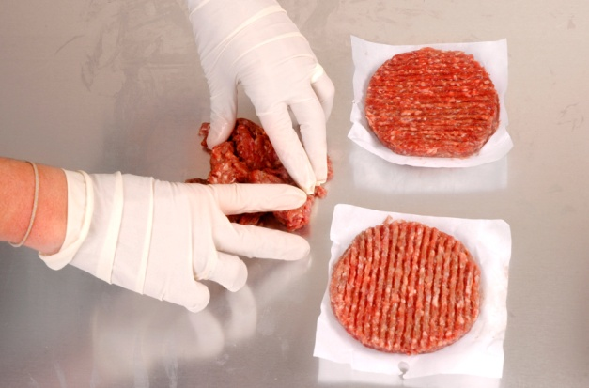
Examples of high risk food handling situations that may include microbiological contamination include:
- Working with any high risk/potentially hazardous foods
- Working in temperatures that promote rapid bacterial growth – that is, in the Temperature Danger Zone (5°C - 60°C). This may occur when raw foods are being processed, prepared for cooking at normal kitchen temperatures
- The amount of time high risk food spends in the Temperature Danger Zone must always be minimised
- Displays of food and buffets – where the temperature may be compromised (hot food may fall below 60°C, cold food may rise above 5°C), plus there is always the danger members of the public (untrained in correct food handling procedures) may contaminate the food
- Processing of food where it is touched by the bare hand and then not subsequently cooked
- Any situation requiring thawing and re-heating always poses a risk because the food may stay in the Temperature Danger Zone too long.

Chemical contamination
Chemical contamination of food can occur:
- As a result of chemicals used on the food when it is grown
- When chemicals find their way inadvertently into the food on the premises due to careless practices in food areas and improper handling of food and chemicals.
Ways to prevent chemical contamination of food
The following practices will help prevent chemical food poisoning:
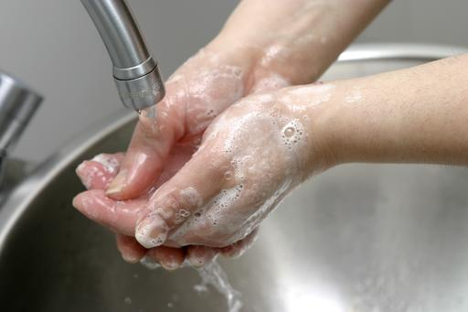
- Specific measuring vessels should always be allocated for chemicals – never use food service items (jugs, glasses, cups, bowls, measuring spoons) to obtain, measure or pour any chemical
- All chemicals must be stored away from food areas at all times – chemicals must never be stored in the kitchen or with food
- Always wash hands after using chemicals and before handling food or food items, utensils or preparation surfaces
- Only buy food from reputable suppliers who can guarantee their produce is chemical-free
- Be aware of alerts advising about contaminated food from a certain location, country or source
- Always wash fruit and vegetables before using them in a sanitising solution
- Cover food whenever it is not being processed/prepared – to protect from contamination by fly sprays and similar.
Naturally occurring poisonous food
Naturally occurring poisonous food are also classified as part of the ‘chemical contamination’ threat.
Consider the following:
- Mushrooms – certain fungi can be poisonous but those purchased from reputable suppliers should be safe
- Do not buy mushrooms from people calling door-to-door, and do not use in a commercial setting mushrooms picked by private individuals
- Rhubarb leaves are poisonous so great care should be given when stemming them
- The stem of the rhubarb is safe to eat
- Green and sprouting potatoes contain a substance called 'solanine' which has been linked with food poisoning outbreaks so green potatoes should be discarded, returned to the supplier or rejected on delivery.

Physical contamination
You must always be on your guard to ensure foreign objects do not find their way into food for human consumption.
Remember, too, the foreign object may have found its way into the food before the product/item arrived at the premises so constant vigilance is required, all the time.
Be on the lookout to guard against:
- Hair from the head or beard
- Metal filings left by can openers
- Flies and insects – and their droppings
- Band-aids
- Bits of glass.
These are only a small sample of possible physical contaminants. The list is endless.

Other food hazards
All the following are examples of food hazards you need to be aware of and constantly searching for:
- Contaminated food – either from the supplier or food that becomes contaminated on-site
- Vermin – including sighting of vermin and evidence of their presence (droppings, webs, holes in the wall, eggs)
- Airborne contamination – either due to natural causes (sand/dust storms, weather) or due to internal causes (dust, renovations)
- Contaminated items – such as linen, tea towels and kitchen swabs that may be contaminated with human waste (blood and secretions) and/or food
- Dirty equipment and utensils – including items not properly cleaned and or sanitised after use, items dropped on the floor and items contaminated by clothing, coughing/sneezing, or cross contamination of any sort
- Garbage – all rubbish/waste presents a potential hazard whether it is stored in bins inside the premises or in containers outside the premises: remember hands must be washed after handing garbage and all garbage containers must be kept clean
- Out-of-date food handling practices – hazards can occur where:
- The nature of the food operations being undertaken have changed – the venue may have changed its service style or undergone some significant change
- The food equipment being used has altered – a new/different oven, fryer or cooking range has been installed

- The food items being processed have changed – new menu items have been introduced.
and there has been no appropriate alteration to the previous food handling protocols to accommodate the risks/hazards introduced by these changes: all food handling practices must be appropriate for the current situation applying in the workplace
- Colleagues with inappropriate training – even where staff have undertaken a food safety course there is no guarantee the lessons they have learned
- Where workers are using incorrect food service practices and/or failing to observe other safe food handling principles (especially in relation to personal hygiene, hand washing) there is a need for re-training
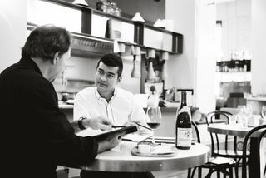
- Equipment not operating as intended by the manufacturers – this typically includes all food processing and holding equipment (especially fridges, freezers, pie warmers and bain maries) as well as thermometers.

Identifying food hazards
The standard ways to identify these hazards are:
- Personal observation – watching what happens in the workplace and being alert to the potential for hazards to arise at any time, any day
- Personal experience with items – your growing body of knowledge with food, procedures, equipment and the workplace will be an invaluable resource in helping identifying problems out-of-control situations and other circumstances posing a risk to food safety
- Analysis of food safety records, documents and logs – where the workplace maintains records of its food activities (temperature record logs; food production sheets; maintenance reports) a regular review of these can reveal issues such as incorrect temperatures (meaning the need for repairs/service to refrigeration units), staff that should be excluded from food handling (on the basis of illness records, injury registers), malfunctioning equipment (via corrective action reports), and food that needs to be disposed of (as indicated by a range of inspection checklists)
- Regular and scheduled workplace inspections (also known as ‘audits’) – designed to verify safe food handling protocols and identify unsafe operations, equipment, areas or protocols.
Whenever an unsafe/unsatisfactory situation has been identified there is a need to:
- Address the cause and take action on unsafe food and contaminated equipment, utensils and food contact surfaces
- Discard and affected (unsafe) food – or food where a suspicion exists that it could be unsafe
- Revise existing operational practices – to prevent a recurrence of the problem and/or address new situations that have arisen
- Clean and sanitise all contaminated utensils, surfaces and equipment involved in the incident – it is not sufficient to dispose of the affected food: the surfaces, equipment or utensils it has made contact with must be cleaned and sanitised
- Implement revised staff training – so new protocols are passed on to food handling staff.

Pest control/Vermin control
Pests, rodents and insects (vermin) are a PR problem in the hospitality industry as customers are shocked by seeing cockroaches, mice, rats and flies in any area of a venue.
If they see these pests, they automatically wonder whether things ‘behind the scenes’ are the same or even worse, and this can cause a loss of trade.
Pests and rodents can cause economic loss to food stocks by leaving droppings in produce, through weevil infestation and by attacking dry foods rendering them useless. The practice of simply scooping droppings out of, say, flour and then proceeding to use it is unacceptable as the animal that left the droppings has probably also urinated and while this may have dried up it still remains and has contaminated the food.
Further economic loss can occur when health authorities intervene and fine the establishment, or close it down due to vermin infestation. The resultant adverse media publicity adds more to loss of patronage/money.
Vermin can also cause severe physical damage to the premises by gnawing through walls, pipes and electrical wiring. Many fires where the cause is an 'electrical fault' are caused by mice eating through live wires.
Pest control must involve an on-going and integrated approach. It cannot be done once a year and forgotten, and all facets of control must be implemented or the program is not effective.
A successful pest control program requires integration of three elements:
- Physical exclusion of pests – also known as ‘Build them out’
- Chemical and mechanical control – also known as ‘Chase them out’
- Sound housekeeping practices – also known as ‘Starve them out’.
Physical exclusion
Physical exclusion involves:
- Checking all deliveries to eliminate pests coming in with foodstuffs
- Correct fitting of fly wire to doors and windows
- Sealing of holes around pipes and other fittings allowing pests entry to the premises
- Exclusion of animals from food areas.

Chemical and mechanical control

Chemical and mechanical control is intended to kill vermin that has entered the premises and includes the use of:
- Electronic fly zappers
- Air curtains
- Traps
- Bait stations
- Sprays
- Fogging.
Sound housekeeping practices
Good housekeeping involves ensuring equipment, floors, benches and other areas are properly cleaned so no liquid or food remains to serve as a food source for vermin.
It should be standard practice for a staff member to get down on their hands and knees and inspect under all food equipment as part of the cleaning and closing procedures – this is intended to identify food scraps that have found their way under such equipment during preparation/service so they can be removed and not left to provide a food source to vermin.
Also involved here is the removal of rubbish and boxes that may provide shelter for them, correct storage of food in vermin-proof containers, and immediate repairs to cracked surfaces and tiles that can also provide a source of food.
You are encouraged to report signs of pest and rodent infestation to management as soon as you notice them.

Food recalls
Need for a recall
A food recall may be initiated by:
- Health or food authorities – usually as a result of advice, for example, from a food manufacturer recommending the recall, or as a result of authority investigations
- Your workplace – if it becomes aware it has prepared and sold food with the potential to cause food poisoning or a risk to public health.
Need for a plan
In general terms, food service businesses may not need to ever recall food but having a plan regarding what to do when the need arises is a sensible thing to do.
When it is determined a situation exists where a food recall is required, the following can serve as a useful basis for your individual workplace food recall plan. Your immediate aims are to:
- Stop distribution and sale of an affected or suspect product
- Remove the affected product from sale
- Notify the customers who, to your knowledge or belief, may have received the affected goods
- Warn the public of the danger.
Identifying and defining the potential hazard
The nature of most food service/retail food businesses is such that any Food Recall will only ever be a ‘Consumer Recall’, involving recovery of the product from consumers within the venue: in most cases, consumers will have either have taken the food away or already eaten the contaminated food before it can be recalled – such is the nature of the industry.
Where an establishment supplies food to other food businesses, a more comprehensive Food Recall plan is required: certainly, the recall requirements will extend to the other food businesses supplied – and speed of recall is crucial.
In assessing whether or not a risk exists (that is, in making a decision to recall food based on facts), consider:
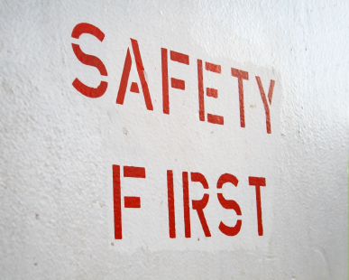
- The gravity of the complaint/defect and the safety implications it poses, basing deliberations on the understanding where there is a risk of death, illness or injury to anyone then a Food Recall is necessary
- The number of complaints/reports received by the premises – regarding ill health, symptoms of food poisoning, the presence of a physical contaminant in the food
- The probability of contamination having occurred during the manufacturing process
- The size and dispersion of the food item(s) in question
- If officials and/or the media have already been notified.
Where you believe a definite risk exists, you must act: it is not acceptable to do nothing and just hope that the problem will go away.
You have a legal duty to act once a problem has been identified.
Recall action steps
The following can provide an effective basis for formulating a Food Recall plan for a food premises, or for action when a need for a food recall is identified:
- Establish the facts of the situation to serve as the basis for the recall and the action to be taken
- Take action – such as:
- Take no action – where no action is needed based on the facts
- Withdraw the product – from sale, distribution or display
- Initiate a food recall – if the product has been sold/distributed outside the premises
- Work out the quantity/volume of food involved and how staff, officials or customers could identify it
- Identify where the product was sold, supplied or distributed from
- Inform customers as soon as possible not to eat the affected product – and ask them to return the food
This can include:
- Notifying anyone sitting down/eating they should stop eating the product
- Notify any individual/group who to your knowledge has purchased the food as a takeaway item not to consume the product: there may be no identifiable individuals or groups, as trade is comprised of the general public (passing trade, local businesses, shoppers, locals and tourists), but in other instances there may be local businesses, tradespeople, schools, who regularly buy from you – your Food Recall plan would require you to pre-prepare a list of these customers in terms of their telephone numbers, fax numbers, street addresses, contact persons in order to facilitate quick contact with them if the need arises
- A full list of in-house patrons (where the premises is a hotel/motel style) should be available from the Front Office reservation computer system
- Patrons who have dined in food outlets may be partially identifiable via the Bookings Book/Sheet in such outlets if this record exists
- Inform your local Health authority – so they can assist with the recall
- Tell the public by (for example) placing warning signs in the venue, placing a food recall notice in local newspapers
- Collect and safely store affected food (labelled as unsafe food and separated from other food) to assist, where needed, with investigations.

2.2 Take action to minimise or remove the risk of food contamination within the scope of individual responsibility

Introduction
Whenever a risk of food contamination has been identified, it must be addressed.
This Section presents possible action to take to address identified food risks and hazards.


Basic requirements
When taking action to address identified food risks or hazards:
- Action must be taken quickly – act immediately as opposed to waiting until the shift/session has finished
- If you cannot fix the problem/remove the risk, you must report it to management
- Only take action if the action falls within your designated ‘scope of authority’
- Audit the safe food handling skills of staff – many food-related problems can be traced to a failure by staff to adhere to required practices and protocols
- Ensure training is appropriate, effective and being implemented to all staff, when and as required
- Check to determine if standard house policies and procedures are being implemented – again, the cause of many problems is a failure to follow house policies and procedures
- Consider involving external experts – to provide objective and professional input regarding the issue/s
- Refer to previous internal and/or external food safety audits – to identify previous similar instances, and to determine any earlier action taken in this regard.

Taking action
When a food safety hazard has been identified, the premises is under a legal obligation to address the issue and make it safe.
Staff are expected to participate in this action within their individually designated scope of authority, and in compliance with all legislated and organisational requirements (such as requirements imposed by policies and procedures, and relevant internal systems for the business).
What action might need to be taken?
The nature of the action to be taken will depend on the hazard that has been identified.
It is impossible to identify/predict the hazards that might occur so the following is a representative list of the possible corrective action that may need to take place.
You will note many ‘corrective actions’ apply to more than one problem/hazard.
Corrective action possibly relating to ‘Purchasing of food’
In relation to hazards relating to the ‘Purchasing of Food’, corrective action may include:
- Obtaining proof from suppliers they are registered as a food supplier and have safe food handling protocols in place
- Adding required/new suppliers to Approved Suppliers List, where necessary
- Setting purchase specifications for suppliers to comply with
- Ensuring food is only bought from businesses listed on the Approved Suppliers List.
Corrective action possibly relating to ‘Receival of food into the premises’
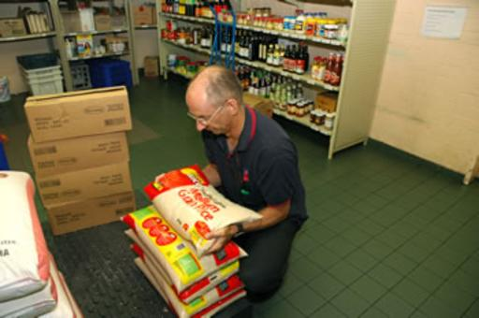
In relation to hazards relating to the ‘Accepting deliveries into the premises’ process, corrective action may include:
- Refusing/rejecting refrigerated high risk foods that are delivered at more than 5°C – unless satisfied it has been outside that temperature for less than 2 hours
- Refusing/rejecting frozen produce not hard frozen
- Refusing/rejecting hot food delivered at less than 60°C – unless you are convinced it has been at this temperature for less than 2 hours
- Refusing/rejecting products which are not adequately marked with manufacturer’s details
- Refusing/rejecting food delivered in an unclean vehicle, or which is being delivered in an inappropriate vehicle such as a private car/vehicle
- Refusing/rejecting foods delivered mixed in with chemicals
- Refusing/rejecting out-of-date foodstuffs
- Refusing/rejecting food items delivered in damaged packages where the integrity of the food may have been compromised
- Refusing/rejecting food items where there is evidence of vermin
- Refusing/rejecting food items that look or smell unacceptable.
Corrective action possibly relating to ‘Dry food storage’
In relation to hazards relating to the ‘Dry food storage’, corrective action may include:
- Where there is evidence of pest or rodent infestation:
- Laying baits
- Engaging the services of a licensed pest control company
- Investigating where they are getting in and making repairs – fitting fly wire, filling in holes
- Throwing away all infested/contaminated food
- Up-dating and/or repairing lighting/globes/fluorescent tubes that have blown – to help identify evidence of vermin, and better identify problems that may be present

- Revamping stock control measures – if there is out-of-date stock
- Throwing away out-of-date food – do not use it
- Allocating more space for dry storage of food where conditions are too crowded/cramped
- Training staff in stock control and/or rotation procedures – if these are not being properly implemented
- Discarding products with damaged packaging
- Revising cleaning protocols – allocating more time, obtaining more/better equipment and/or chemicals, providing training in cleaning, cleaning the area more frequently.
Corrective action possibly relating to ‘Storage of refrigerated food’
In relation to hazards relating to the ‘Storage of refrigerated food’, corrective action may include:
- Discarding all food exceeding the 2/4 rule
- Discarding all food beyond its use-by date, or similar
- Training staff in cleaning techniques and practices
- Calling in a refrigeration mechanic where the refrigeration units are reading above 5°C: consider implementing a preventative maintenance schedule through a reputable refrigeration company to help ensure all refrigeration remains in proper working order all the time
- Discarding all food where there is evidence – or even just a belief –cross contamination has occurred
- Revamping stock control and rotation procedures, as/if required
- Revamping cleaning procedures, as/if necessary.
Corrective action possibly relating to ‘Storage of frozen food’
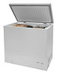
In relation to hazards relating to the ‘Storage of frozen food’, corrective action may include:
- Where frozen food has thawed out but is still below 5°C, staff are allowed to refrigerate it and then treat it as refrigerated food
- Where frozen food has been allowed to reach 5°C or higher (perhaps the freezer has broken down or there has been an extended power failure) for less than 4 hours – it may be used within 4 hours
- If the frozen food has been at 5°C or more for more than 4 hours – throwing it out
- If the frozen food has been at 5°C or more for an indefinite amount of time – that is, there is uncertainty about how long it has been at 5°C or above – discard it all
- Discarding all food exceeding the 2/4 rule
- Discarding all food beyond its use-by date, or similar (‘best before’ date)
- Training staff in cleaning techniques and practices
- Calling in refrigeration mechanic where the freezer units are reading above -15°C: again, consider implementing a preventative maintenance schedule through a reputable refrigeration company
- Discarding all food where there is evidence – or a belief –cross contamination has occurred
- Revamping stock control and rotation procedures, as/if required
- Revamping cleaning procedures, as/if necessary.
Corrective action possibly relating to ‘Thawing of frozen food’
In relation to hazards relating to the ‘Thawing of frozen food’, corrective action may include:
- Training staff to wait until food is fully thawed before cooking – food remaining frozen/partially frozen must not be cooked until it has fully thawed
- Training staff in proper thawing practices, including the need to plan defrosting needs
- Discarding all food exceeding the 2/4 rule
- Throwing out all food that is defrosted in an uncovered state, or which has defrosted in damaged packaging
- Discarding all food that has been thawed and re-frozen
- Training staff not to freeze thawed product.

Corrective action possibly relating to ‘Food preparation’
In relation to hazards relating to ‘Food preparation’, corrective action may include:
- Ensuing sufficient time and resources to facilitate compliance with correct food handling practices – this may be providing gloves, extra utensils (knives, chopping boards, bowls), and/or providing more time (for hand washing, for doing things properly, for cleaning)
- Placing signage in the workplace to prompt/remind staff of correct/safe food handling practices
- Revamping preparation procedures and practices so as to minimise time food spends in the Temperature Danger Zone – this may include spending time planning food preparation activities on a daily basis, or food item by food item basis
- Improving stock control and rotation procedures – if out-of-date items are being identified during this phase
- Applying the 2/4 rule – to all potentially hazardous foods
- Changing cleaning cloths regularly – at least hourly: consider using disposable paper towels instead of cloths
- Monitoring the performance of individual staff members in relation to food preparation and food safety issues, and suggesting improvements to practice where this is deemed necessary: train/re-train staff as required.
Corrective action possibly relating to ‘Cooking food’
In relation to hazards relating to ‘Cooking food’, corrective action may include:

- Ensuring food reaches 75°C or above – check the temperature in the thickest part of the meat, or in the middle of the pot/container: use a probe thermometer (not guesswork or an infra-red thermometer) to read the temperature
- Ensuring all soups, stews and sauces reach 75ºC
- Placing signs in the workplace to prompt/remind staff of correct/safe cooking practices
- Recording the times, temperatures and processes associated with the production of two high risk foods once a month on an ‘Internal Review – Process Temperature’ log or similar to verify correct practices are being adhered to
- Ensuring tasting of food is done with spoons not then used to stir the dish – to avoid cross contamination
- Covering food during the cooking process as far as is practicable – to protect from airborne contamination, flies
- Cleaning and sanitising pots and all items used for cooking – and storing them under clean conditions when they have been cleaned and sanitised
- Minimising the time food spends in the Temperature Danger Zone – this requires the cooking procedure to quickly attain a temperature above 60°C: This may mean food produced using a low temperature/long time cooking process cannot use in a commercial setting.

Corrective action possibly relating to ‘Cooling of hot food’
In relation to hazards relating to ‘Cooling of hot food’, corrective action may include:
- Ensuring the Two-Step rule for the cooling of potentially hazardous hot foods is being applied
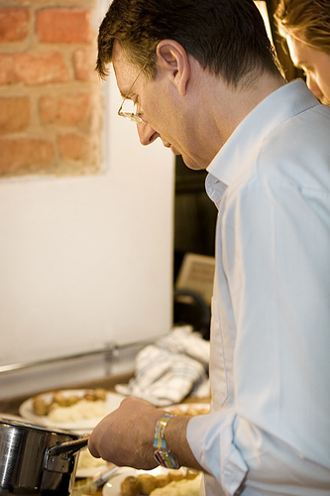
- Helping hot foods to cool down by placing hot pots/containers into iced water baths – to speed up the cooling process
- Stirring wet dishes – to help release heat
- Covering cooling dishes – to protect against contamination
- Setting clocks, watches or alarms to notify of required timeframes – so cooling foods are not forgotten and left ‘too long’ at room/cooling temperatures
- Making sure new staff at any change of shift are notified in relation to any food that is cooling – so they can take over management of the cooling food
- Verifying thermometer readings – by calibrating food thermometers at least every six months
- Training staff as required in cooling procedures
- Placing signs around the workplace to remind staff of what is required in relation to the cooling of food.
Corrective action possibly relating to ‘Storing and holding of hot food’
In relation to hazards relating to ‘Storing and holding of hot food’, corrective action may include:
- Training staff as required – in relation to practices such as food handling, heating of food, food display, stock rotation and cleaning protocols
- Revamping hot holding procedures – to ensure food stays at or above 60°C
- Checking operational efficiency and accuracy of all hot holding equipment – and providing professional service/maintenance to units as required
- Pre-heating all food properly (to 75°C) prior to placing it into hot holding devices – pre-heated food must be placed into pre-heated units
- Ensuring temperatures of all hot held food are being taken as required using a properly calibrated thermometer – to verify correct holding temperatures are being achieved
- Revising display protocols if tags, price signs, product descriptions are actually touching food
- Revamping times when bain maries and pie warmers are turned on – turning them on earlier to allow sufficient time for them to get to 60°C or above
- Operating bain maries and/or pie warmers at higher settings so as temperature of food reaches 60°C.

Corrective action possibly relating to ‘Storing and holding of cold food’
In relation to hazards relating to ‘Storing and holding of cold food’, corrective action may include:
- Training staff as required – in (as appropriate) food handling, cooling of hot food, display of food, stock rotation and cleaning protocols
- Revamping cold holding procedures – to ensure food stays at or below 5°C
- Checking operational efficiency and accuracy of all cold holding equipment and providing required/regular service and/or maintenance
- Ensuring all food going into cold display units is already at or below 5°C – pre-chill units before loading them with cold food
- Ensuring temperatures of all cold held food are being taken as required using a properly calibrated thermometer
- Revising display protocols if tags, price signs, product descriptions are actually touching food
- Revamping times when cold display are turned on – turning them on earlier to allow sufficient time for them to get to 5°C or below
- Operating units at lower settings so as food reaches 5°C or less.
Corrective action possibly relating to ‘Re-heating of food’
In relation to hazards relating to ‘Re-heating of food’, corrective action may include:
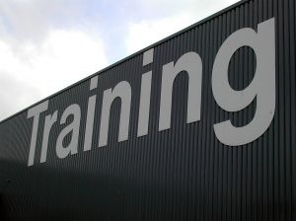
- Revamping re-heating procedures to ensure 75°C or higher for at least 2 minutes is attained, and display/holding protocols ensure 60°C or higher is maintained
- Altering re-heating practices – to re-heat quicker and/or in smaller quantities
- Throwing out re-heated food failing to reach a core temperature of 75°C or higher
- Training staff – as required.
Corrective action possibly relating to ‘Service of food’
In relation to hazards relating to the ‘Service of food’, corrective action may include:
- Discarding all food exceeding the 2/4 rule
- Training staff in correct food handling and serving practices
- Providing sufficient equipment and utensils to enable separate (and multiple) utensils for each food item
- Maintaining food holding equipment so the required holding temperatures for hot and cold food can be obtained
- Altering the settings on units so required display/holding temperatures can be achieved.

Corrective action possibly relating to ‘Self-Service of food’
In relation to hazards relating to the ‘Self-Service of food’, corrective action may include:
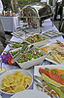
- Preparing and placing food handling signage/advice near the food – advising customers of what to do, and what not to do in order to enhance food safety
- Considering alternative serving options – if the safety/integrity of food cannot be guaranteed where self-service is used
- Allocating additional staff to observe customer food handling practices – and help/take action where required
- Discarding all food exceeding the 2/4 rule
- Training staff in correct monitoring procedures – and in appropriate customer relations skills to facilitate compliance with requirements
- Providing sufficient equipment and utensils to enable separate (and multiple) utensils for each food item
- Maintaining food holding equipment so the required holding temperatures for hot and cold food can be obtained
- Altering the settings on units so the required display/holding temperatures can be achieved.
Record the corrective action taken
Whenever any action is taken to address a hazard/out-of-control situation this action should be documented on a ‘Corrective Action Sheet/Report’ or similar.
Recording corrective action taken should not be regarded as an ‘admission of guilt’ in relation to an out-of-control situation – rather, it should be seen as a positive indication you were actively monitoring food safety and took appropriate action when the need to do so arose.

2.3 Handle and dispose of food waste and rubbish in compliance with enterprise standards and legislated requirements

Introduction
Correct handling and disposal of food waste and other rubbish is an important food safety consideration as waste is a major source of contamination.
This Section identifies standard food safety requirements applying to the handling and disposal of food waste and rubbish in a food premises.

Cleaning waste containers and rubbish areas
All bins – internal and external – should be maintained in a sound condition (that is working properly, no leaks) and kept clean.
There is no requirement to sanitise bins but this may be a house rule in some food premises.
Cleaning an internal bin may require a simple wipe with a cloth dipped in hot water and detergent.
Cleaning an external bin may require the use of a gong brush, high pressure hose, detergent, degreaser and deodoriser.
The external waste area must also be kept clean to avoid attracting pests and to help control smells. A yard broom can be used to sweep the area and a high pressure hose used with detergent and a deodoriser.

Internal disposal of rubbish and waste food
What does this mean?
Internal disposal of rubbish and waste food refers to the removal of these items from inside the premises.
In practice this means emptying bins located in the:
- Kitchen
- Food preparation areas
- Dish washing areas
- Back-of-house food areas.
When should it be done?
Some premises have policies and procedures about when bins need to be emptied, but most do not, instead relying on staff common sense to determine when this needs to be done.
It is a standard requirement waste never be allowed to accumulate.
Common times for emptying bins include:
- When they are nearly full – never wait until they are full as this encourages over-filling which results in waste/food falling out of the bins and onto the floor
- At the end of a service session – such as ‘after lunch’, ‘after dinner’
- At a specific time of the day – ‘at 2:00PM’, ‘at 10:00PM’
- After a nominated time has elapsed – ‘every 30 minutes’, ‘every hour’.
What is involved?
Emptying a bin may involve:
- Putting on protective gloves – depending on the nature of the rubbish/waste in the bin these may disposable gloves or gauntlets
- Picking up anything lying around/near the bin – to remove it from the floor and put it in the bin
- Tying a knot in the plastic bin liner – to prevent waste falling from the bag
- Removing the plastic bin liner – carefully looking for signs of breakage and/or leaking
- Placing a new bin liner into the bin – and securing it in place according to the type of bin liner and/or bin
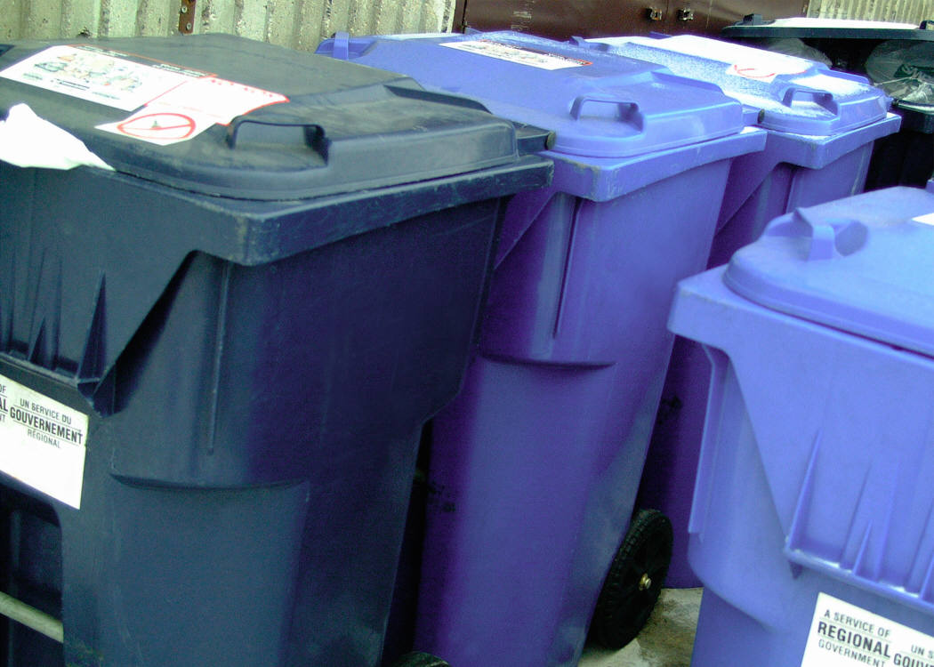
- Taking the bin liner/rubbish bag to the designated outside/external rubbish area – which may be a rubbish bin or dumper
- Opening the required bin and placing the bin liner/bag into it – making sure all the contents go into the bin or dumper
- Closing the lid on the bin or dumper – to help prevent access to food waste by pests and vermin
- Washing hands – making sure not to wash them in a sink used for food preparation.
You may also need to:
- Obtain help from another person to lift/move the bin
- Clean the floor area under and around the bin that has been emptied – with detergent and sanitiser, drying the area to help avoid slips
- Clean the inside and outside of internal bins at least daily – many food premises clean their internal bins after each service session, using detergent and (where necessary) a de-greasing agent.

Removal of food and other waste from the external premises
Removal of food and other waste from the external premises refers to ensuring rubbish and food waste in outside (‘external’) bins and/or dumpers is removed from the premises.
Waste in external areas must also never be allowed to accumulate.
Rubbish is commonly removed by the local council or a private company on a fee-for-service basis.
Food premises should supply sufficient bins or receptacles to cater for whatever rubbish/waste is produced. If rubbish is scattered all around the existing bins, and it is flowing over the tops of bins, more bins need to be provided.
The rubbish area must be also be kept in a clean and tidy condition – in general rubbish must be stored in such a way as to minimise contamination and avoid providing harbourage for cats, vermin and birds.
Frequency of disposal of the external rubbish must reflect the amount and type of rubbish/waste generated.
The use of commercial companies to clear this rubbish may be required: attention should be paid to increasing garbage pick-ups during peak trading periods (due to increased amount of waste created) and hot weather (due to the potential for objectionable smells to be created).
All garbage bins must be in good condition and must exclude pests which usually means they will have to be fitted with tight-fitting lids which must be kept in position so as to provide protection against vermin gaining access to the rubbish.

Re-cycling options
It is standard practice for all venues to re-cycle their waste wherever possible.
This may require sorting waste into separate bins or containers as follows:
- Plastics
- Cardboard and paper
- Glass – jars and bottles
- Cans, tins and metal products.
Actual food waste is not sorted/re-cycled but simply thrown out in general waste.
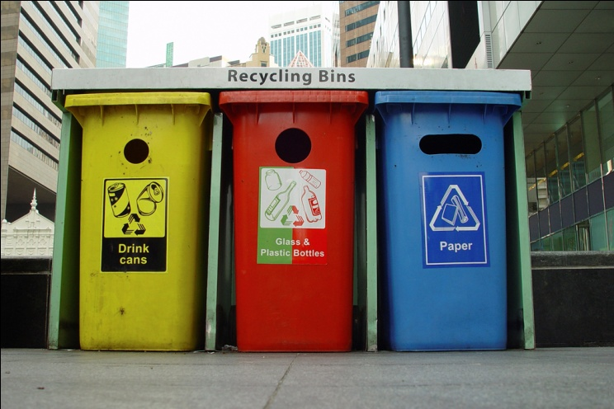
Work Projects
It is a requirement of this Unit you complete Work Projects as advised by your Trainer. You must submit documentation, suitable evidence or other relevant proof of completion of the project to your Trainer by the agreed date.
2.1 For the workplace where you work as a food handler:
- Identify three potential food risks presented by the food being processed on the premises (at any stage from receipt of food into the premises to the service of food to customers)
- Identify three potential personal/staff-related food risks
- Identify three potential environmental food risks
- Describe for each identified risk how an actual hazard may be identified
- Describe how each identified hazard could be prevented and effectively addressed once identified.
2.2. Supply photographs or video showing you handling and disposing of food waste and rubbish in your workplace.
The photographs or video must demonstrate you have complied with all necessary internal and legislated requirements for the safe handling of waste/rubbish by a food handler.

Summary

Identify and prevent hygiene risks
When identifying and preventing hygiene risks:
Be constantly alert for workplace food hygiene/safety risks and hazards
Understand food safety can be compromised from microbiological sources, chemical sources, chemical sources and other sources such as airborne contamination
Use observation and experience to identify possible hygiene risks in the workplace
Physically exclude vermin from food areas, use chemical and other controls to eradicate them and implement sound housekeeping practices to deter them
Plan for the possibility of food recalls
Report any food safety problem you cannot fix
Ensure corrective action in relation to food safety is taken promptly and addresses the identified cause as well as all food and any food items, equipment, utensils and food contact surfaces involved
Record corrective action taken
Dispose of internal and external waste in accordance with house requirements
Wash hands after handling waste
Keep external waste areas clean and vermin free
Clean and maintain all internal and external rubbish containers
Do not allow the accumulation of waste either internally or externally
Re-cycle waste as appropriate.

Element 3:
Maintain safe personal food handling and personal presentation standards

3.1 Identify the enterprise standards and legislated requirements that apply to personal practices and presentation for food handling staff

Introduction
In addition to safe food handling practices and protocols, enterprise standards and legislated requirements can also apply to the personal practices and presentation of food handling staff.
This brief Section addresses how these workplace requirements can be identified.

Ways to identify what is required
You can identify the enterprise standards and legislated requirements applying to personal practices and personal presentation of food handling staff in your workplace by:
- Speaking with management, your supervisor and more experienced staff to ask them what requirements apply
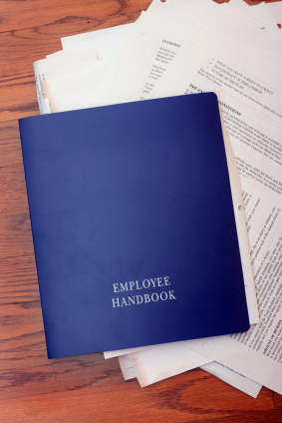
- Reading company policies and procedures applying to food – including those relating to safe food handling, staff work practices, personal hygiene, personal presentation and staff sickness.
These policies and procedures may be available:
- In a staff handbook
- In a ‘Policies and procedures manual’ available for inspection by staff in staff rooms, meal rooms and change rooms
- Through an in internal intranet system
- As checklists and posters in the workplace – strategically located to provide staff with on-the-spot directions to help create and maintain a safe food environment
- Attending all mandatory in-house training – many employers require all food handlers to attend and successfully complete a ‘basic food hygiene’ course (or similar) before they are allowed to handle food in any way.
Some employers require all food handlers to have completed an externally conducted, and accredited/approved, food safety course in addition to internal training (or as an alternative to it)
- Observing practices of other staff/food handlers – and following their lead
- Asking questions – of trainers, supervisors, other staff, co-workers
- Talking to health authorities – and asking them what applies and what you need to comply with.

3.2 Follow enterprise standards and legislated requirements that apply personal practices and presentation for food handling staff

Introduction
All the enterprise standards and legislated requirements identified in the previous Section must be adhered to at all times by food handlers.

This Section addresses common requirements in this regard such as those relating to staff uniform and hand washing as well as presenting important factors to note regarding personal sickness/illness of food handlers and personal habits while at work.

Uniforms
Most food establishments require you to wear a nominated uniform or other personal protective clothing when working.
The following requirements apply to the wearing of uniforms for food handlers:
- Protective clothing (apron, hat, coat, trousers) worn by food handlers must be clean – dirty clothing may directly or indirectly contaminate food and/or food preparation equipment or surfaces
- You are obliged to ensure your clothing does not contaminate food or food-related equipment, utensils or surfaces
- Clothing that becomes dirty and a risk to food must be changed – to avoid cross contamination. Outer clothing needs to be changed when it has become soiled as a result of handling exposed (that is, not packaged) high risk raw food and there is then a need to handle exposed ready-to-eat food
- Protective clothing such as aprons, overalls, hats, gloves and other outer protective clothing/equipment should be removed before visiting the toilet.
Ensuring clothing or other items worn do not contaminate food
You must take care to ensure none of your clothing or other items you wear will contaminate the food you handle.
The biggest cause of concern in this regard is items falling into the food and present a physical contamination problem, and clothing making contact with food or food contact surfaces and providing a source of cross contamination.

Clothes
Practical measures to help guard against contamination from clothes include:
- Ensure uniform/food handling clothes are not loose
- Ensure buttons on food handling clothes are not loose
- Avoid adding brooches, name tags, clips, pins to clothes – unless they are securely fastened and unable to fall off
- Do not wear food handling clothes to and from work.
Jewellery
Practical measures to avoid food safety problems from jewellery include:

- As a food handler avoid all jewellery – and watches – on hands and wrists.
Even plain, banded rings can cause a potential food poisoning source.
Disposable gloves should be when handling food if these are worn.
Some house rules ban the wearing of all jewellery by food handlers
- Do not wear ear-rings – ear-rings that dangle are the worst but not wearing them at all is preferable.
Sleepers may be acceptable but check house rules first
- Avoid fiddling/playing with jewellery – especially ear-rings in pierced ears.
This can cause cross contamination and also loosen items making them more likely to fall off.
Hair ornaments
Practical measures relating to the wearing of hair ornaments for food handlers include:
- Do not wear hair clips or hair pins
- As a food handler it is preferable to wear no hair ornaments at all
- If something is worn in the hair, double-check to ensure it is securely fastened in place
- Wear a hair net or hat to guard against items falling out of the hair and into food or into food preparation equipment or onto food preparation surfaces.

Hand washing
Health authorities believe the single most important aspect in preventing food poisoning outbreaks is for food handlers to wash their hands properly and to wash them ‘when required’.
When must food handlers wash their hands?
All food handlers are required to wash their hands before or after nominated activities.
The intention is to ensure the hand washing process removes potential food poisoning sources from the hands so the possibility of cross contamination is reduced.
The times when food handlers must wash their hands are:

- Any time the hands are likely to be a source of contamination – this can cover a wide range of possible circumstances and it is impossible to identify them all but the following is a representative list:
- After handling rubbish/garbage and before handling food or food contact surfaces
- After undertaking cleaning duties and before handling food or food contact surfaces
- After handling animals and before handling food or food contact surfaces
- After changing a baby’s nappy and before handling food or food contact surfaces
- After handling money and before handling food or food contact surfaces
- In between handling raw food (meat, fish or chicken) and handling other foods such as cooked and/or ready-to-eat food
- Before starting food handling duties – this means food handling staff must wash their hands when they arrive at work even though they may have showered, bathed or washed their hands at home before coming to work
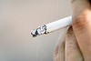
- Immediately after engaging in nominated activities proven to be associated with bacterial transfer/cross contamination. The nominated activities include:
- Smoking – including using tobacco products
- Coughing or sneezing
- Using a handkerchief or nasal tissue – which includes blowing the nose
- Eating or drinking
- Touching hair, scalp, mouth, nose, ears, any body opening or any wound.
- After any absence from the work station – this means every time a food handler leaves the kitchen (or other place where they are handling food), they must wash their hands on their return to work and before they handle food. These absences from the work station may involve or be caused by:
- Leaving the kitchen to accept a delivery of food into the premises from a supplier
- Taking a phone call
- Doing another job that is not a food-related task
- Immediately after using the toilet and before handling food or food contact surfaces – this applies to all instances where the toilet was used and includes a requirement to wash hands after urination as well as after defecation.

Organisational requirements
All food handling premises are entitled to impose policies and procedures exceeding any applicable minimum legal requirements.
This means, for example, a food handling premises may require food handlers to wash their hands every 30 minutes or every hour regardless of what activities they are engaged in.
A business may also require staff to wash their hands in the wash hand basin in the toilet after using the toilet, and then wash their hands again when they re-enter the kitchen/food area.
Where the workplace has hand washing requirements exceeding the mandatory minimum requirements, always adhere to nominated workplace practices.
Obligations on employers
To allow food handlers to wash their hands as required, employers should provide and maintain permanent and readily accessible hand washing facilities wherever food handlers are likely to have hands that are a source of contamination – including providing those facilities in toilets.
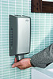
These hand washing facilities should:
- Be supplied with a continuous supply of warm running, potable water – the accepted temperature of this water to be 40ºC
- Be supplied with soap – most food premises use bulk soap dispensers dispensing liquid anti-bacterial soap: the use of bars of soap is to be avoided as the soap can transfer bacteria
- Only be used for washing hands, arms and face – the wash hand basins must not be used for other purposes such as a food preparation sink.
Sinks in the kitchen/food preparation area used for other purposes (washing vegetables, preparing food) must not be used for hand washing
- Be of an appropriate size enabling the effective washing of hands
- Be supplied with appropriate means of drying the hands – this can be single-use (paper) towels and hot air dryers
It is not acceptable for a business to provide only a hot air dryer.
Re-usable towels can be used provided they are washed and dried after every use – this is extremely unlikely to happen in most businesses so the preferred option is to use paper/disposable towel.
- Be supplied with a bin – for disposing of used disposable towels.
Consideration should also be given to providing a nail brush so proper hand washing (including cleaning under the fingernails) can occur.

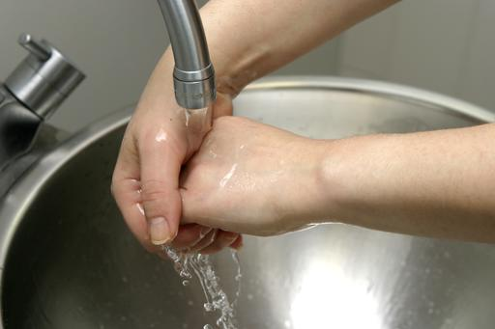
How to wash hands
The following must be implemented when food handlers wash their hands.
The requirements are food handlers ‘thoroughly clean’ their hands, meaning they must:
- Rinse off visible and easy to remove dirt
- Wash their hands for at least 20 seconds, minimum
- Thoroughly and vigorously massage the soap into the folds and creases of the hands and wrists
- Clean under the fingernails
- Rinse the soap from the hands
- Thoroughly dry the hands – the preferred method of drying hands is to:
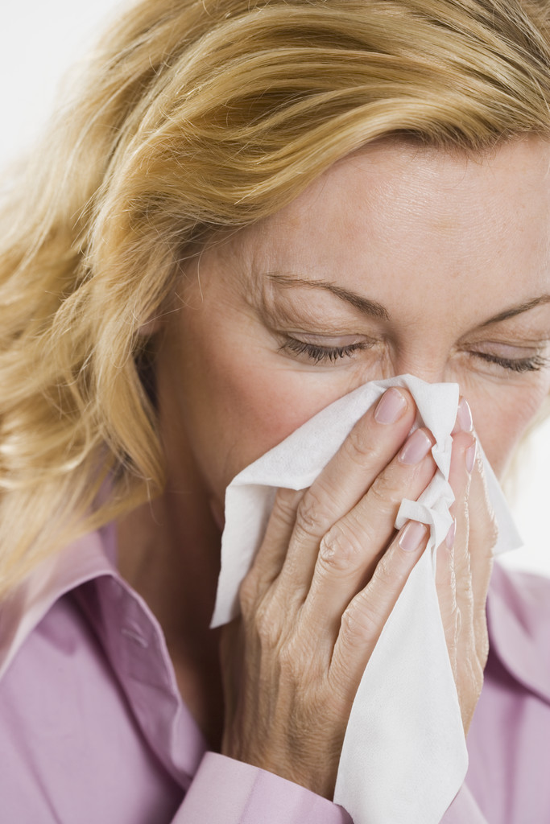
- Shake off excess water
- Dry with paper towel
- Finish with hot air dryer.

Personal sickness, illness and injury
Body fluids
Body fluids include body secretions which include saliva, mucus, sweat and blood, urine and faecal matter.
Food handlers should take the following practical measures to prevent contamination of from body fluids include:
- Washing hands thoroughly after using the toilet
- Washing hands thoroughly after handling a handkerchief or nasal tissue to cough or sneeze into, and/or using it to blow the nose
- Refraining from spitting in any food area
- Refraining from smoking or chewing tobacco in any food area
- Staying away from work when suffering cold or flu symptoms – and obtaining a doctor’s certificate stating as a food handler it is safe to return to work
- Observing all personal hygiene rules
- Avoiding the tasting of food with a spoon and then returning the utensil to the food
- Wearing a sweat band – or mopping areas that sweat and then thoroughly washing hands: consider wearing anti-perspirant
- Covering all cuts and sores with approved waterproof dressings and bandages – and adding a finger stall and/or disposable glove, as appropriate
- Not blowing with the breath into a bag to be used to wrap food – such as take away foods
- Not wetting fingers to assist with separating sheets of wrapping paper when packaging take away foods
- Not touching anybody opening – such as ears, eyes, nose: thorough hand washing must occur if this happens.
Report personal health issues likely to cause a risk
It is important to take immediate and effective action if you are ill or suffering from symptoms indicating a food-borne disease.
Management have a role in excluding ill workers from food handling duties but this does not absolve you of your responsibility to take appropriate action to protect food safety where you work.
What is a food-borne disease?
A food-borne disease is a disease likely to be transmitted through food.
A list of pathogens and the names of the relevant diseases are presented below at ‘Tables of pathogens transmitted by food contaminated by infected food handlers’.
Food handlers will not know if they are actually suffering from a food-borne disease until they are diagnosed by their doctor but they may be experiencing symptoms indicating this is a possibility.
Category 1, 2, or 3?
Food handlers must determine whether they fit into one of three identified categories when deciding what to do.
Category 1 – Suffering from symptoms of a food-borne disease
If a food handler is suffering from:
- Diarrhoea
- Vomiting
- Sore throat with fever
- Fever
- Jaundice.
They are deemed to be showing symptoms of a food-borne illness unless they can attribute the symptoms to something else.
Where a food handler has any of these symptoms they must advise their supervisor and should seek immediate medical attention. Food handlers should stay away from work for 48 hours after their symptoms have disappeared and they are able to produce ‘formed stools’.
Category 2 – Having definite knowledge of suffering from a food-borne disease
Where a food handler knows they are suffering from a food-borne illness (as listed in tables below) they will have had their condition diagnosed by a doctor.
Some food-borne diseases pose greater food safety risks that others, so knowing the name of the disease is important when determining what action must be taken in relation to the duties they can undertake and the precautions that need to be taken.
Category 3 – Being a carrier of a food-borne disease
A carrier is someone who has no symptoms of the disease but is capable of spreading the disease by contaminating food.
A person will only know they are a carrier if they have been diagnosed as such by their doctor.
What to do if in relation to these identified categories

A food handler who is suffering from a symptom of a food-borne disease, or who knows they are suffering from a food-borne disease, or knows they are a carrier of a food-borne disease must:
(1) Notify their supervisor
They must tell their supervisor of their suspicions or their knowledge of their illness, explaining their suspicions, situation, symptoms and/or disease.
(2) Abstain from handling food
The food handler must not handle food where there is chance they could contaminate it, or contaminate food-related equipment and/or utensils.
It may be prudent to always adopt a ‘worst case’ scenario when determining what activities the affected food handler can or cannot engage in.
(3) Take appropriate measures to prevent food contamination
If the food handler remains at work undertaking other duties (administrative or cleaning duties) they must ensure they do not come into contact with food, or food contact services, equipment, cutlery of crockery.
Where the premises is unable to provide appropriate ‘other duties’, the food handler should be excluded altogether from the food handling business.
What must happen if the food handler is suffering from ‘a condition’?
A condition is an infected sore, cut, boil, acne or abrasion or a situation where the food handler experiences discharges from their ears, nose or eyes.
Where a food handler is suffering from such a condition they must notify their supervisor unless they:
- Do not have direct contact with food, food contact surfaces, crockery, cutlery or glassware
- The skin lesion is on a covered part of the body so he sufferer cannot touch it while handling food.
If the food handler does continue working (whether food handling or other work activities) they must ensure measures are taken to avoid contaminating food – these measures may include:
- Covering the lesion completely with a waterproof bandage or dressing
- Not touching the lesion or discharge
- Washing hands thoroughly if the lesion or discharge is touched
- Using appropriate medication for the problem
- Using disposable tissues to handle discharge, followed by proper hand washing – as opposed to using a handkerchief, a kitchen towel or a kitchen swab.
The food handler’s responsibility
Food handlers are required to ban themselves from all food handling activities where they believe their health poses a contamination risk to food and/or food surfaces, equipment, utensils, crockery, cutlery and glassware.
Failure to do so can lead to outbreaks of food poisoning, and the tests health authorities perform can readily identify the person responsible for the outbreak.
If a food handler is identified as the cause of such an outbreak and they knowingly continued to work – or have knowingly contaminated food – they may be subject to criminal and civil action.
The message is simple – if ill, stay away from food handling duties.
Tables of pathogens transmitted by food contaminated by infected food handlers
Pathogens often transmitted by food contaminated by infected food handlers
Name of pathogen | Name of disease
Hepatitis A | Hepatitis A
Norwalk and Norwalk-like viruses | Norwalk disease or Norwalk-like disease
Salmonella typhi | Typhoid fever
Shigella species | Shigellosis
Staphylococcus aureus | Staphylococcal disease
Streptococcus pyogenes | Streptococcal disease
Pathogens occasionally transmitted by food contaminated by infected food handlers
Name of pathogen | Name of disease
Campylobacter jejuni | Campylobacter enteritis
Entamoeba histolytica | Amoebiasis
Enterohaemorrhagic Escherichia coli | Diarrhoea caused by Escherichia coli  (enterohaemorrhagic strains)
Enterotoxigenic Escherichia coli | Diarrhoea caused by Escherichia coli  (enterotoxigenic strains)
Giardia lamblia | Giardiasis
Non-typhoidal Salmonella | Salmonellosis
Rotavirus | Rotaviral enteritis
Taenia solium | Taeniasis
Vibrio cholerae O1 | Cholera
Yersinia enterocolitica | Yersiniosis
(Source: Safe Food Australia, p. 84.)

Controlling personal habits

Nearly all food handlers have sub-conscious habits they need to control to help maintain the safety of food in the workplace.
Coughing and sneezing
Try to refrain from coughing or sneezing onto unprotected food – where a cough or sneeze is inevitable (or unexpected) and unprotected food is present, the recommended procedure is to:
- Cough or sneeze into hands and then thoroughly wash hands
- Dispose of any food that has been contaminated
- Clean and sanitise any food surfaces, equipment or utensils that have been contaminated.
Picking, scratching and touching
As a food handler you must cultivate the discipline to not scratch yourself (such as scratching an itch; scratching your head when thinking), pick your nose, cuts, sores and scabs, or touch your eyes, nose, mouth or ears while at work.
This is another major source of contamination transferring infection/bacteria from the skin or other areas to food, utensils or food preparation/contact surfaces.
If you have picked or scratched yourself:
- Dispose of any food that has been contaminated
- Clean and sanitise any food surfaces, equipment or utensils that have been contaminated
- Try not to do it again.
Eating in food areas
When staff eat in food areas they must:
- Not eat any food over an unprotected food surface – such as food preparation equipment, preparation benches, serving equipment or crockery, cutlery or glassware
- Not eat any food over any unprotected food – this applies to raw food, ready-to-eat food or any food that is not covered, wrapped or packaged so that it cannot become contaminated through food falling onto it.

Note: individual premises may have house policies totally forbidding the consumption of food while working.
Note also the above requirements in relation to eating over unprotected food and unprotected food surfaces applies to anyone on the premises – including members of the public, customers and visitors.
Smoking and spitting
In any food area you must never:
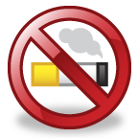
- Smoke
- Chew tobacco
- Spit.
It is a good idea to put up ‘No Smoking’ posters in all food areas and to remove ash trays from these areas.
If you smoke outside the work/food area remember you must wash your hands before returning to work to remove any bacteria transferred from the mouth/lips to the fingers as part of the smoking process.

Work Projects
It is a requirement of this Unit you complete Work Projects as advised by your Trainer. You must submit documentation, suitable evidence or other relevant proof of completion of the project to your Trainer by the agreed date.
3.1 You have been asked to inform a new food handler about the requirements applying in relation to personal practices and presentation of food handlers at your workplace.
Prepare a comprehensive list of information you would communicate to this new staff member covering:
- Personal hygiene requirements
- Requirements applying when the person is feeling unwell or ill – including notifications to be made and documentation involved
- Action required if they believe their health has compromised the safety of food on the premises
- Internal requirements applying to food handlers in relation to:
- The wearing of hats/hair nets
- Beards and facial hair
- Hand washing
- Wearing of jewellery
- Nail polish and nail decorations
- Personal habits and the need to control them.

Summary

Maintain safe personal food handling and personal presentation standards
When maintaining safe personal food handling and personal presentation standards:
Learn the legislated and house rules applying to safe personal activities and presentation in the workplace
Wear a clean uniform when handling food as required by the business
Do not wear food handling clothes to and/or from work
Limit or eliminate jewellery, hair ornaments and nail polish/decorations when working as a food handler
Wash hands when and as required using only designated hand washing facilities – always wash hands before starting work and when returning to work after an absence from the work station
Do not work with food when ill or suffering from symptoms of foodborne illnesses
Obtain a doctor’s certificate stating you are fit to return to work as a food handler if you have been away from work due to illness/sickness
Control personal habits which can give rise to food contamination when handling food.

Presentation of written work

1. Introduction
It is important for students to present carefully prepared written work. Written presentation in industry must be professional in appearance and accurate in content. If students develop good writing skills whilst studying, they are able to easily transfer those skills to the workplace.

2. Style

Students should write in a style that is simple and concise. Short sentences and paragraphs are easier to read and understand. It helps to write a plan and at least one draft of the written work so that the final product will be well organized. The points presented will then follow a logical sequence and be relevant. Students should frequently refer to the question asked, to keep ‘on track’. Teachers recognize and are critical of work that does not answer the question, or is ‘padded’ with irrelevant material. In summary, remember to:
- Plan ahead
- Be clear and concise
- Answer the question
- Proofread the final draft.

3. Presenting Written Work
Types of written work
Students may be asked to write:
- Short and long reports
- Essays
- Records of interviews
- Questionnaires
- Business letters
- Resumes.
Format
All written work should be presented on A4 paper, single-sided with a left-hand margin. If work is word-processed, one-and-a-half or double spacing should be used. Handwritten work must be legible and should also be well spaced to allow for ease of reading. New paragraphs should not be indented but should be separated by a space. Pages must be numbered. If headings are also to be numbered, students should use a logical and sequential system of numbering.
Cover Sheet
All written work should be submitted with a cover sheet stapled to the front that contains:
- The student’s name and student number
- The name of the class/unit
- The due date of the work
- The title of the work
- The teacher’s name
- A signed declaration that the work does not involve plagiarism.
Keeping a Copy
Students must keep a copy of the written work in case it is lost. This rarely happens but it can be disastrous if a copy has not been kept.
Inclusive language
This means language that includes every section of the population. For instance, if a student were to write ‘A nurse is responsible for the patients in her care at all times’ it would be implying that all nurses are female and would be excluding male nurses.
Examples of appropriate language are shown on the right:
Mankind | Humankind
Barman/maid | Bar attendant
Host/hostess | Host
Waiter/waitress | Waiter or waiting staff

Recommended reading
Australia New Zealand Food Authority (ANZFA), January 2001 (2nd ed’n), Safe Food Australia: A Guide to the Food Safety Standards, Australia New Zealand Food Authority, Canberra.
Ballard, C., 2010, Food safety, Gareth Stevens Publishing, Pleasantville, NY.
Brown, M., 2010 (6th ed’n), Safe food handling, Chisholm Institute of TAFE, Dandenong, Victoria.
CSIRO, 2010, Make it safe: a guide to food safety, CSIRO Publishing, Collingwood, Victoria.
D’Mello, J.P.F., 2003, Food safety: contaminants and toxins, CABI Publishing, Oxford.
Hickman, A., 2008, Follow workplace hygiene procedures: SITXOHS002A, William Angliss Institute, Melbourne, Australia.
Hickman, A., 2008, Implement food safety procedures: SITXFSA001A, William Angliss Institute, Melbourne, Australia.
Knowles, T., 2002, Food safety in the hospitality industry, Butterworth-Heinemann, Boston, Mass.
Marriott, N.G. & Gravani, R.B., 2006 (5th ed’n), Principles of Food Sanitation, Springer, New York, NY.
Redman, N., 2007 (2nd ed’n), Food safety: a reference handbook, ABC-CLIO, Santa Barbara, California.
Internet site
http://www.health.vic.gov.au/foodsafety/bus/templates.htm
http://www.health.vic.gov.au/foodsafety/bus/index.htm
http://www.foodstandards.gov.au/consumerinformation/foodrecalls/

Trainee evaluation sheet

Comply with workplace hygiene procedures
The following statements are about the competency you have just completed.
Please tick the appropriate box | Agree | Don’t Know | Do Not Agree | Does Not Apply
There was too much in this competency to cover without rushing.
Most of the competency seemed relevant to me.
The competency was at the right level for me.
I got enough help from my trainer.
The amount of activities was sufficient.
The competency allowed me to use my own initiative.
My training was well-organized.
My trainer had time to answer my questions.
I understood how I was going to be assessed.
I was given enough time to practice.
My trainer feedback was useful.
Enough equipment was available and it worked well.
The activities were too hard for me.

The best things about this unit were:

The worst things about this unit were:

The things you should change in this unit are:

Trainee self-assessment checklist
As an indicator to your Trainer/Assessor of your readiness for assessment in this unit please complete the following and hand to your Trainer/Assessor.

Comply with workplace hygiene procedures
 |  | Yes | No*
Element 1: Follow hygiene procedures
1.1 | Identify relevant workplace hygiene procedures that need to be adhered to
1.2 | Identify enterprise standards and legislated requirements that apply to relevant workplace hygiene procedures
1.3 | Follow workplace hygiene procedures in accordance with enterprise standards and legislated requirements
1.4 | Receive, handle and store all food items according to enterprise standards and legislated requirements
1.5 | Prepare, serve and store food in compliance with enterprise standards and legislated requirements
1.6 | Clean food-related items, utensils and areas in compliance with enterprise standards and legislated requirements
Element 2: Identify and prevent hygiene risks
2.1 | Identify potential food, personal, environmental and other risks in the workplace promptly
2.2 | Take action to minimise or remove the risk of food contamination within the scope of individual responsibility
2.3 | Handle and dispose of food waste and rubbish in compliance with enterprise standards and legislated requirements
Element 3: Maintain safe personal food handling and personal presentation standards
3.1 | Identify the enterprise standards and legislated requirements that apply to personal practices and presentation for food handling staff
3.2 | Follow enterprise standards and legislated requirements that apply personal practices and presentation for food handling staff
Statement by Trainee:
I believe I am ready to be assessed on the following as indicated above:
Signed: _____________________________ | Date: ____________
Note:
For all boxes where a No* is ticked, please provide details of the extra steps or work you need to do to become ready for assessment.





